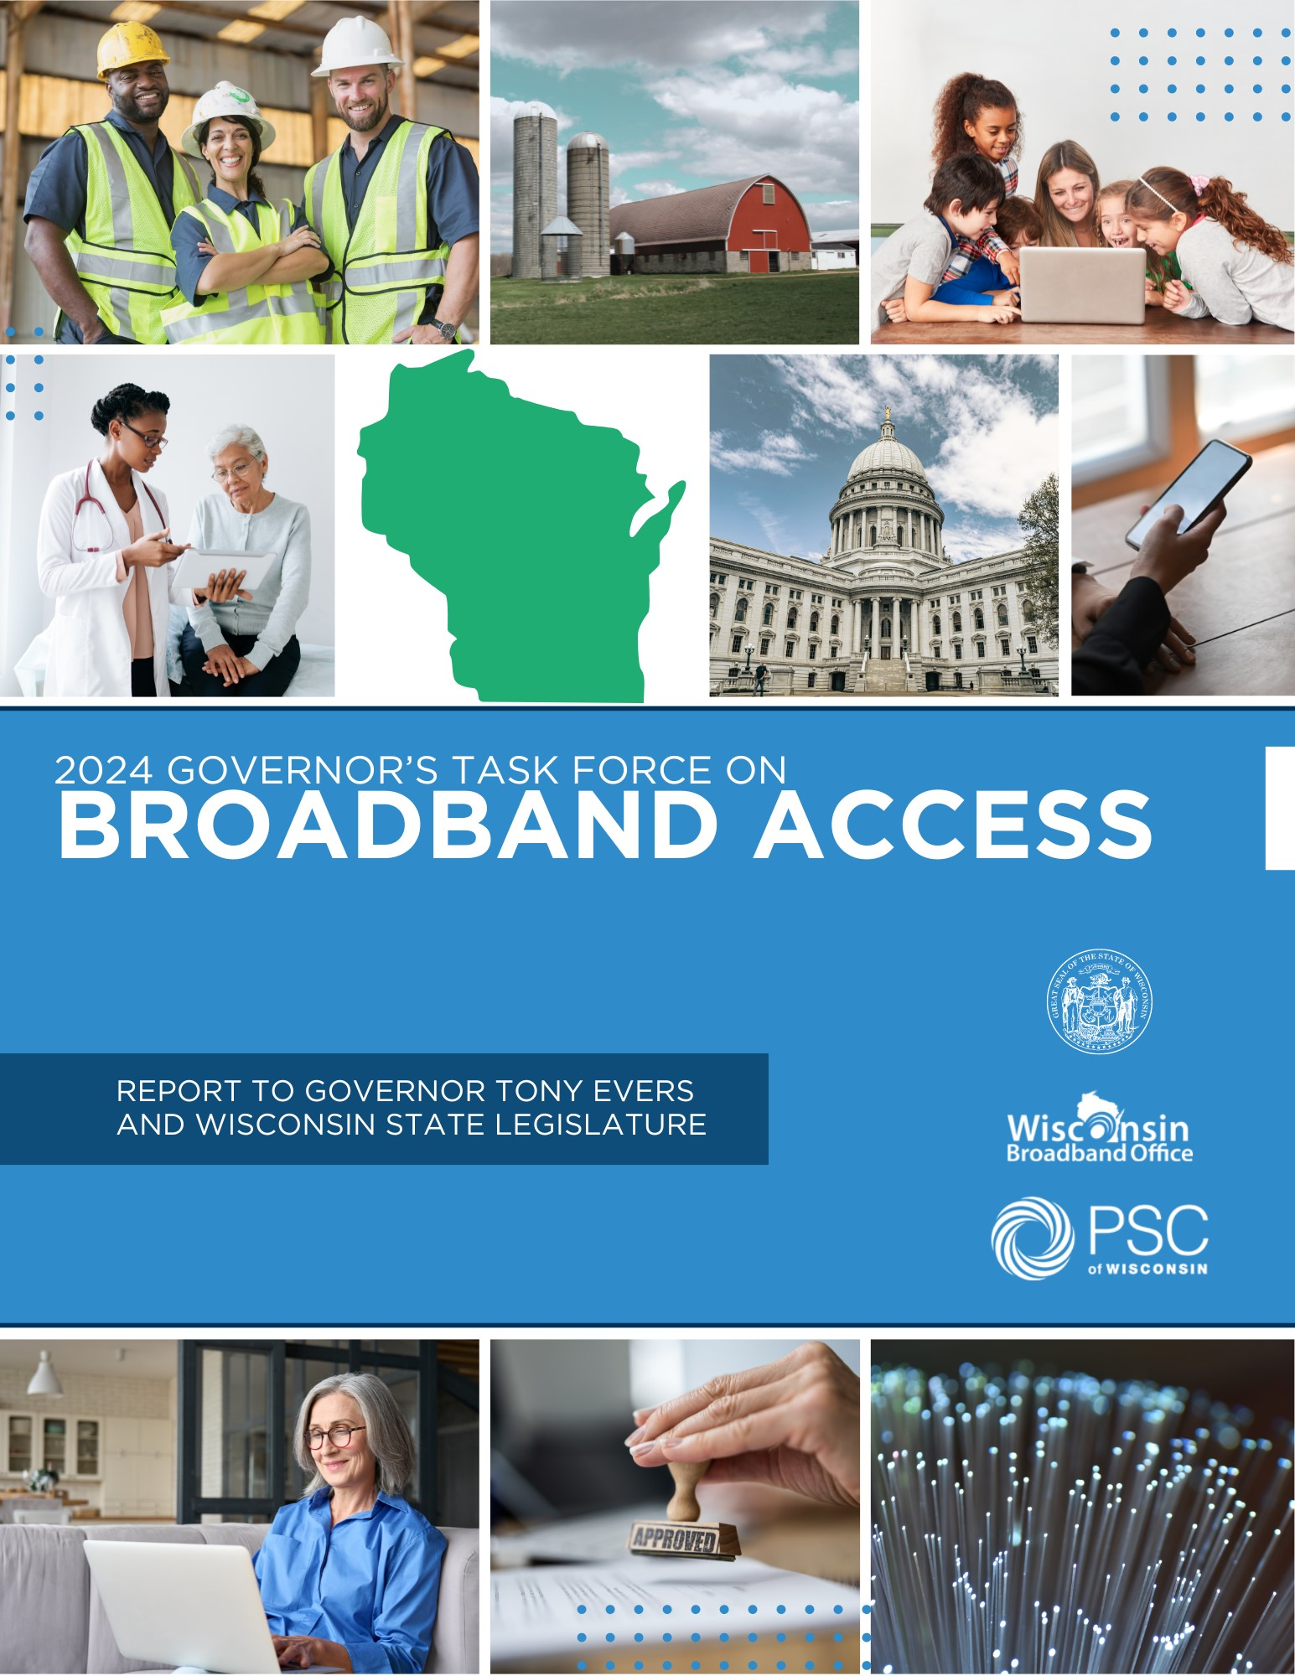

**TABLE OF CONTENTS**

EXECUTIVE SUMMARY ……………………………………………………………………………………………………………………………………. 3  
  
TASK FORCE MEMBERS …………………………………………………………………………………………………………………………………… 7  
  
LETTER FROM PSC CHAIR, SUMMER STRAND ……………..………………………………………..………………………………………… 9  
  
LETTER FROM TASK FORCE CHAIR, CHRIS MEYER …………………………………………………………………………………………. 11  
  
ACKNOWLEDGEMENTS …………………………………………………………………………………………………………………………………. 13  
  
TASK FORCE PROCESS AND METHODOLOGY …………………………………………………………………………………………………. 14  
  
CURRENT STATE OF BROADBAND ACCESS ……………………………………………………………………..……………………………… 16  
  
CURRENT STATE OF DIGITAL EQUITY ……………………………………………………..……………………………………………………… 21  
  
IN PROGRESS: STATE AND FEDERAL FUNDING FOR INFRASTRUCTURE, ADOPTION, AND EQUITY …………………. 25  
  
PROGRESS UPDATE: RECOMMENDATIONS FROM PRIOR YEARS……………………………………………………………………. 31  
  
TASK FORCE RECOMMENDATIONS …………………………..…………………………………………………………………………………… 36  
  
CONCLUSION ………………………………………………………………………………………………………………………………………………… 48

# EXECUTIVE SUMMARY

This is the fourth annual report of the Governor’s Task Force on Broadband Access. Since the Task Force’s last report, the Wisconsin Broadband Office (WBO) at the Public Service Commission (PSC) wrapped up its planning efforts under the Bipartisan Infrastructure Law’s (BIL) Internet for All initiative by submitting the Wisconsin Digital Equity Plan and Broadband Equity, Access, and Deployment (BEAD) Five-Year Action Plan. WBO has now transitioned from planning to implementing Internet for All, including submitting the Initial Proposal for the BEAD Program, and applying for Digital Equity State Capacity funds to implement its Digital Equity Plan. In addition, WBO awarded 30 Capital Project Funds (CPF) Infrastructure grants to expand broadband infrastructure and opened applications for the CPF Digital Connectivity and Navigators Program to deploy multi-dwelling unit Wi-Fi and digital devices supported by digital navigators to leverage those assets.

As in the previous year, this year the Task Force continued to focus on gathering input from people and organizations that could inform the rollout of and timely implementation of BIL programs, as well as continued efficient and impactful administration of state programs. The Task Force also examined how to address the issue of broadband affordability with the ending of the Federal Communications Commission (FCC) Affordability Connectivity Program (ACP).

In 2024, the Task Force continued to emphasize its goals established in the 2023 report, which are that:

* **By 2028/2029, all homes and businesses will have access to high-speed broadband service that reliably provides a download speed of at least 100 Mbps and an upload speed of at least 20 Mbps.**
* **By 2028/2029, all community anchor institutions (CAI) will have access to high-speed broadband service that reliably provides a download speed of at least 1000 Mbps and an upload speed of at least 1000 Mbps.**
* **Where practicable, a strong emphasis and priority should be placed on reaching “future proof” speeds beyond 100/20, up to and including 1000/1000 Mbps for as many homes, businesses, and community anchor institutions as possible.**
* **Fiber technology should be prioritized, but not exclusively required, for public investments where practicable. Also, terrestrial fixed wireless solutions should be pursued in harder to reach areas or as an incremental short-term solution.**

The Task Force believes that all Wisconsinites should have the information technology capacity needed for full participation in our society, democracy, and economy. Broadband access is an essential catalyst for economic development, rural prosperity, educational opportunities, access to essential services, community health, entertainment, agriculture, quality of life, aging in place, and so much more across Wisconsin. Access alone will not meet our goals; internet adoption, digital literacy, and affordability are key components of equitable and sustainable access. Solving Wisconsin's broadband challenges calls for a multifaceted strategic approach, with input from a variety of stakeholders.

This year the Task Force focused on three areas, as described in the recommendations below: Preparing for BEAD, Continued Investment in State Broadband Programs, and Affordability & Adoption.

## PREPARING FOR BEAD

**Utility, Telecommunication and Broadband Facility Locating**

* Increase the availability of design and engineering information for grant-funded broadband deployment projects to empower more efficient locating efforts during BEAD.
* Establish a compliance system and monetary penalties to hold telecommunications utilities and internet service providers (ISP) accountable for failure to complete locates within required time period.
* Explore feasibility of requiring broadband deployment projects to pre-mark their planned construction route prior to requesting a facility locate to ensure expedited and accurate locating efforts.
* Consider establishing a confidential clearinghouse that would share as-built data from ISPs on a limited basis to streamline locating and permitting.

**Permitting**

* Support permit planning and increase analysis of permitting needs by publishing and distributing guidance, maintaining web maps and tools to identify potential permitting jurisdictions, and providing technical assistance.
* Increase permitting coordination by acting as a liaison and advocate between internet service providers and the federal government and advocating for and supporting efficient permitting compliance processes.

**Workforce and training**

* Allocate funding and state resources to support workforce training and credentialing programs to ensure a sufficient and trained workforce for internet service providers and contractors, to construct, operate and maintain current and new broadband infrastructure.
* Through funding and technical assistance, support and include organizations such as workforce development boards, economic development organizations, labor groups and unions, contractors, high schools, higher education and technical colleges, and state agencies (DPI, DWD, PSC) in workforce planning efforts, youth apprenticeship opportunities, and retraining existing workers. Ensure that these organizations are being connected with internet service providers and telecommunications associations to increase awareness of employment opportunities and create a sustainable and viable talent pipeline.
* Where practicable and with input from employers and higher education, incentivize hiring from within local communities to help retain local talent and grow good jobs within Wisconsin. Collaborate with local community organizations and educational entities to cultivate community engagement and establish a robust talent pipeline.

**Grant Administration**

* Continuously improve, implement, and streamline grant administration and compliance processes that ensure efficient, transparent, and accountable use of public funding.
* Enhance processes to streamline reporting, reimbursement, contracting, and compliance processes to reduce the cost and burden on recipients of state and federal funds and ensure timely and accountable deployment of public funding for the largest public benefit.
* Provide technical assistance to grantees related to meeting compliance and reporting requirements, and widely distribute informational materials and technical assistance opportunities.

**Tribal Coordination**

* Support Tribal Nations located in Wisconsin in their deployment efforts by providing technical assistance for participation in BEAD. Wisconsin Broadband Office (WBO) should work to ensure tribal partners are aware of timelines and urgency of the BEAD Program.
* Encourage and support coordination with Tribal Nations considering and developing partnerships with neighboring local governments and internet service providers.
* Collaborate with Tribal Nations to ensure consent is given for any grant funded project affecting Tribal lands and to ensure provider compliance with permitting and historic preservation requirements.

## CONTINUED INVESTMENT IN STATE BROADBAND PROGRAMS

* Invest additional state budget funding for broadband expansion to address gaps left behind after BEAD process. Target state funding in areas where experienced speeds differ from advertised service due to aging and less-reliable technology, and where prior federal funding awards default and are left incomplete.
* Consider line extension funding to help bridge gaps in installation costs of broadband.
* Where feasible, strategically braid state broadband expansion funding with federal funds to build more locations with fiber and reduce BEAD’s reliance on less reliable technologies in more remote, less resourced areas of Wisconsin.

**AFFORDABILITY AND ADOPTION**

* Advocate for the continuation of affordability programs, through federal action to provide ongoing funding for the Affordable Connectivity Program or its successor, or through state action to create a state internet affordability program for low-income households. Consider internet service provider feasibility and financial sustainability in the implementation of affordability initiatives and allocation of grant funding.
* In the absence of additional funding, provide consumer resources and respond to public inquiries during the wind-down of ACP to ensure members of the public are informed about alternative internet discount options and able to retain internet access.
* Expand the breadth and impact of Lifeline by encouraging more internet service providers to become eligible telecommunications carriers (ETC) and more current ETCs to apply the Lifeline discount to broadband service. Work to increase marketing and outreach about the state and federal Lifeline programs and maintain state and federal verification tools for affordability programs.
* Research, measure, and establish a standardized affordability threshold for internet service in Wisconsin and consider the business case in understanding financial viability for providers absent state and federal funds to support affordability.
* Update the State Broadband Expansion grant criteria to include cost of service or affordability for low-income households as part of the score.
* Leverage federal Digital Equity funding to establish and maintain an ecosystem of informed and engaged digital equity practitioners and coalitions that obtain state, federal, and philanthropic funding to improve adoption.
* Ensure all Wisconsinites have access to an internet enabled device(s) and assistive technologies, that meet their needs, including for telehealth, education, job readiness, and workforce development.
* Research, endorse, and share digital navigator and digital literacy support best practices, including curricula, for use by practitioners. Pursue partnerships with public libraries, school districts, and nonprofits to develop training programs and toolkits to disseminate these digital navigator and literacy best practices.
* Elevate and support adoption efforts with funding and resources for local broadband champions, digital equity practitioners, and trusted local partners with experience in implementing adoption initiatives. Conduct outreach and increase engagement on adoption and digital literacy and work with communities with historical and institutional barriers to internet adoption.
* Ensure all Wisconsin residents and communities have accessible, first-language, culturally responsive technical support. Wisconsin residents should have access to community-based technical support from anchor institutions, trusted organizations, and individuals, that is affordable and accessible.

# TASK FORCE MEMBERS

Governor Evers appointed members to the Task Force on Broadband Access to provide balanced perspectives, reflect individual’s knowledge or expertise, or to represent an organization engaged in the expansion of broadband access, adoption, or affordability. The Governor’s Task Force on Broadband Access members include:

**Chris Meyer (Chair)**, Vice President– IT Innovation and Efficiency

**Bob Abrams**, Senior Managing Consultant, BKD (ret.)

**Robert Earl Baker III**, Founder, RenderTech

**Kwami Barnes**, Broadband Coordinator, Communications Workers of America

**Marta Bechtol**, Executive Director, Educational Communications Board

**Brittany Beyer**, Community Economic Development Specialist, University of Wisconsin-Madison, Division of Extension

**Salvador L. Carranza**, Board Member, Latino Academy of Workforce Development

**Shannon Clark**, CEO & General Manager, Richland Electric Cooperative (retired in 2022)

**Lori Collins**, President/CEO, SonicNet Inc.

**Douglas Cox**, Director of Land Management, Menominee Indian Tribe of Wisconsin

**Angie Dickison**, State Government Affairs Manager, TDS Telecommunications

**Emily Dittmar**, Legislative Director, Wisconsin Educational Media and Technology Association

**Russ Falkenberg**, Board Member, Ntera, LLC

**Celeste Flynn**, Director of Government Affairs, Charter Communications

**Chris Her-Xiong**, Executive Director/Principal, Hmong American Peace Academy

**Justin Huebner**, CEO and General Manager, Solarus

**Gail Huycke**, Community Development Broadband Outreach Specialist, University of Wisconsin – Madison, Division of Extension

**Barbara Koldos**, Vice President of Business Development, New North, Inc.

**Howard Marklein**, State Senator (R-Spring Green)

**Jose Martinez**, Vice President, UMOS

**Jeffrey Mursau**, State Representative (R-Crivitz)

**Brad Pfaff**, State Senator (D-Onalaska)

**Melissa Ratcliff**, State Representative (D-Cottage Grove)

**Rachel K. Schemelin**, E-Rate and Broadband Education Consultant, Wisconsin Department of Public Instruction

**Steve Schneider**, President and Director, Bug Tussel Wireless

**Michelle Schuler**, Manager of TechSpark Wisconsin, Microsoft

**Brett Schuppner**, General Manager, Reedsburg Utility Commission

**Josh Shell**, President, Badgerland Connections

**Dr. Chet Strebe**, Associate Vice President of Information Technology, Chief Information Officer, Northcentral Technical College

**Chad Young**, CEO/General Manager, Norvado

# LETTER FROM PSC CHAIR, SUMMER STRAND



Four years ago, Governor Tony Evers created the Task Force on Broadband Access to advise state leaders on strategies to improve internet access, affordability, and adoption in Wisconsin. Since then, the task force has studied the issues, raised awareness, gathered input, and delivered policy recommendations to the governor and the state legislature to help bring broadband to all.

I am honored to serve as Chairperson of the PSC and support Governor Evers and his Task Force as we work to connect all homes and businesses to high-speed internet. In this role, I have witnessed how broadband expansion efforts benefit communities across Wisconsin. I attended several Internet for All Listening Tour stops in northern Wisconsin where I heard from community organizations, Wisconsinites, Tribal leaders, and elected officials about the importance of affordable and accessible high-speed internet. While splicing fiber at a technician training center in Waunakee, I learned about broadband technologies and workforce development initiatives. These firsthand experiences emphasized the impact broadband infrastructure has on our economy, our everyday lives, and the future of our state.

Under Governor Evers’ leadership, significant progress has been made to bridge Wisconsin’s digital divide. Since 2019, the PSC has awarded grants to help more than 410,000 homes and businesses access new or improved broadband services. Together we created a digital equity plan that addresses affordability and adoption needs of Wisconsin residents. We have cultivated strong partnerships with local leaders, community-based organizations, internet service providers, and more to help us achieve critical broadband expansion milestones. Our momentum continues as we are now ready to implement President Biden’s Internet for All initiative from the Bipartisan Infrastructure Law he championed. The Task Force devoted significant time and attention to help plan for the deployment of this historic investment to make progress toward our collective goal that every resident has access to reliable, affordable, high-speed internet.

This 2024 Report of the Governor’s Task Force on Broadband Access provides key policy recommendations that were developed after many months of strategic planning and discussion. It highlights, yet again, the positive impact the Task Force has on our state while still underscoring the need for the state to make additional investments to continue this important work and reach our ambitious goals of getting all Wisconsinites connected to high-speed broadband service in this decide. With the next biennial budget on the horizon our administration looks forward to working with state leaders to make meaningful, significant investments in order to execute these recommendations.

The work undertaken by the Task Force has been a great team effort and I appreciate everyone involved in this important initiative. I would like to thank Chris Meyer for serving as Chair of the Task Force and Kristin Runge from UW-Extension for facilitating Task Force discussions. Thanks also to each member for their contributions and service. Last but certainly not least, a huge thank you to the Wisconsin Broadband Office team for their support of the Task Force and continued dedication to providing accessible and affordable high-speed Internet for All residents of the State of Wisconsin.

There is still a lot of work ahead of us, but I am confident that under Governor Evers’ leadership and with the Task Force’s support, we can meet our internet access, affordability, and adoption goals.

Sincerely,



**Summer Strand**

Chairperson, Public Service Commission of Wisconsin

# LETTER FROM TASK FORCE CHAIR, CHRIS MEYER



I am honored to present the fourth annual Report of the Governor’s Task Force on Broadband Access. This year has been a significant one in our ongoing mission to connect every Wisconsinite to reliable broadband.

Thanks to the tireless efforts of our dedicated task force members, PSC, Broadband Office Staff, stakeholders, partners, and Governor Evers, we have made substantial progress on connecting every Wisconsinite to reliable broadband service.

**Key Achievements:**

* **BEAD Preparation:** With over $1 billion in federal funding identified for Wisconsin, we focused on preparing the state for the Broadband Equity, Access, and Deployment (BEAD) Program by developing recommendations to streamline grant administration, permitting processes, and workforce development. These recommendations, included in this report, will be crucial for maximizing the impact of BEAD funding.
* **Continued Investment:** We recognize that BEAD alone will not solve the entire broadband gap. The Task Force advocated for continued state investment to target underserved areas and ensure all residents have access.
* **Affordability:** The Task Force explored strategies to ensure broadband affordability, including supporting existing programs and researching a potential state-level initiative.
* **Digital Adoption:** Recognizing the importance of not just having access but also using broadband, the Task Force developed recommendations to promote digital literacy and adoption efforts.

**Looking Forward:**

The coming year will be critical in implementing these plans and ensuring all Wisconsinites benefit from the opportunities broadband offers. We remain committed to working collaboratively with all stakeholders to achieve this goal, and work together to ensure the needed state investments to pair with federal funding are realized.

I want to express my sincere gratitude to the Task Force members for their expertise and dedication and to the dedicated staff at the Public Service Commission’s Broadband Office for their coordination of meetings and presentations as well as development of this report.

Together, we are making a real difference in the lives of Wisconsin residents and moving our state FORWARD.

Sincerely,



**Chris Meyer**

Chair, Governor’s Task Force on Broadband Access

# ACKNOWLEDGEMENTS

We would like to acknowledge several individuals for their participation and effort in making this Task Force a success.

Thank you to our presenters, including:

* **Gail Huycke**, Community Development Broadband Outreach Specialist, University of Wisconsin – Madison, Division of Extension
* **Chris Stark**, Digital Equity and Inclusion Outreach Specialist, University of Wisconsin – Madison, Division of Extension
* **Jessica Beckendorf**, Community Development Broadband Outreach Specialist, University of Wisconsin – Madison, Division of Extension
* **Kathy Jennings**, Broadband Utility Coordinator, Wisconsin Department of Transportation
* **Scott Nyman**, CEO, Cirrinity/Wittenberg Telephone Company
* **Angie Dickison,** State Governmental Affairs Manager, TDS
* **Justin Huebner**, CEO/General Manager, Solarus
* **Brett Schuppner**, General Manager, Reedsburg Utility Commission/Light Speed
* **Rachel Schemelin,** Education Consultant, Department of Public Instruction
* **David Berka,** Project Manager, United Way of Greater Milwaukee & Waukesha County/Techquity
* **Kristi Waits,** Director of Special Projects, Northwest Wisconsin Workforce Investment Board
* **Thami Hastings**, EveryoneOn, Senior Project Manager
* **Diana Rodriguez**, EveryoneOn, Vice President of Programs and Strategy
* **Bill Niemuth,** VicePresident, Boulder Junction Highspeed Broadband Expansion Committee

And thank you to:

* **Kristin Runge**, Ph.D., Communication Research Specialist at the University of Wisconsin – Madison, Division of Extension for her help with facilitation, exploration, and coordination of Task Force meetings.
* Wisconsin Broadband Office and other Public Service Commission of Wisconsin staff for their work on Task Force meetings and this report, including: **Sawyer Boldt, Sarah Curtin**, **Joe Fontaine**, **Alyssa Kenney**, **Tara Kiley, Josie Lathrop**, **Mark Leonard**, **Christina Luna, Matthew Marcus**, **Katie Mumm**, **Samantha Olivieri, TJ Pyzyk, Tom Scholten, Colter Sikora**, **Annette Smith**, **Jennifer Smith**, **Meghan Sovey**, and **Rory Tikalsky**.

# TASK FORCE PROCESS AND METHODOLGY

The Governor’s Task Force on Broadband Access (Task Force) was established by Governor Tony Evers under [Executive Order 80](https://evers.wi.gov/Documents/EO/EO080-BroadbandTaskForce.pdf) on July 14, 2020. Task Force members are selected and appointed by Governor Tony Evers. On January 4, 2023, Governor Tony Evers issued [Executive Order 182](https://evers.wi.gov/Documents/EO/EO182-RecreatingNonStatCommittees%20(002).pdf), relating to the recreation of Non-Statutory Committees, including this Task Force.The Task Force’s charge is:

"Advise the Governor and Wisconsin State Legislature on broadband actions and policy, including strategies for successfully expanding high speed internet access to every residence, business, and institution in the state; initiatives for digital inclusion; and pathways to unlocking and optimizing the benefits of statewide, affordable access to broadband for all communities in Wisconsin.”

In the spring of 2022, the National Telecommunications and Information Administration (NTIA), a part of the U.S. Department of Commerce, published a notice of funding opportunity for the BEAD Program. The Task Force and its leadership recognized that the $1.06 billion in funding would enable broadband stakeholders to pursue several recommendations from previous years and make significant progress in addressing access across Wisconsin. As a result, the overall work plan and monthly agendas were designed to advise and support the State of Wisconsin as it prepares to receive and distribute BEAD funding. Recommendations from previous reports that were especially helpful in this task were elevated as the 2023-24 Task Force undertook its work this year.

This year’s Task Force began its work in August 2023 and concluded in June 2024. The work of the Task Force was coordinated by a five-member team which included Task Force Chair Christopher Meyer, Wisconsin Broadband Office Broadband Planning and Policy Coordinator Mark Leonard, the State Broadband and Digital Equity Director Alyssa Kenney, Broadband Expansion Manager Rory Tikalsky, and University of Wisconsin Division of Extension (UW Extension) Community Economic Development Specialist Dr. Kristin Runge, who served as Task Force facilitator. The coordination team held debrief meetings after each Task Force meeting, met monthly, and communicated through email to plan the meeting agenda, invite speakers, identify potential resources useful to the Task Force, and monitor progress towards Task Force goals.

A total of eight Task Force meetings were held from August to May. From January to June, meetings focused on identifying and refining recommendations. Prior to several meetings during the information gathering phase of the Task Force, members reviewed and responded to a series of preparation questions focusing on different aspects of Task Force recommendations. These answers were collected via Qualtrics survey, summarized, and then reviewed and discussed at each meeting. After an initial draft of recommendations in early April, the Task Force members were asked to rate each potential recommendation. The ratings were then used as the basis for discussion when Task Force members refined recommendations.

In the first portion of each meeting, the Task Force heard updates from the PSC and presentations from invited agencies and stakeholders on topics relevant to the day’s topic. In the second portion of each meeting, Task Force members participated in a facilitated discussion related to both the day’s presentations as well as pre-work that was assigned via Qualtrics. Discussions were designed to capture Task Force member’s knowledge and were structured such that there were either whole group discussions or initially met as small groups before discussing as a whole group. PSC staff members served as facilitators during the small group discussions, recording comments and input onto a publicly viewable Google document that served as a temporary workspace. The Google documents were downloaded for preservation, and then used as a resource during the writing of the report and its recommendations.

The Task Force continued to meet virtually in its fourth year. Meetings were conducted via Zoom, and a link was made available as part of the publicly posted agenda. Each meeting included time for public comment.

**PRESENTATIONS TO AND WORK OF THE TASK FORCE**

**August 2023**

* Remarks by Wisconsin Governor Tony Evers
* Remarks by Public Service Commission Chairperson Rebecca Cameron Valcq
* BEAD Planning Presentation from Wisconsin Broadband Office
* Boston Consultant Group Presentation on Broadband Intelligence

**October 2023**

* Wisconsin Digital Equity Plan Presentation from Wisconsin Broadband Office
* BEAD Planning and Capacity Building Presentation from University of Wisconsin-Madison, Division of Extension
* State Challenge Process Presentation by the Public Service Commission

**November 2023**

* Permitting Presentation from Wisconsin Department of Transportation
* Locating Presentation from Cirrinity/Wittenberg Telecommunications
* Update from the Public Service Commission

**January 2024**

* Federal Broadband Funding Presentation from the Wisconsin Broadband Office
* Panel Discussion on EACAM and RDOF Funded Projects

**February 2024**

* Remarks by Public Service Commission Chairperson Summer Strand
* Updates from the Public Service Commission
* Presentation: Adoption of Broadband and Affordability Impact on Schooling by Wisconsin Department of Public Instruction
* Panel Discussion on Digital Equity Outreach Programs

**March 2024**

* Presentation: Boulder Junction Public-Private Partnership Presentation
* Updates from the Public Service Commission
* Presentation: Overview of Past Task Force Discussions by Wisconsin Broadband Office

**April 2024**

* Updates from the Wisconsin Broadband Office.
* Discussion of 2024 Task Force Annual Report Recommendations

**May 2024**

* Discussion of Goals for Annual Report

# CURRENT STATE OF BROADBAND ACCESSS

During 2023, the accuracy of broadband availability maps continued to improve, and tens of thousands of Wisconsinites got access to new fiber internet service. FCC released its fourth version of the location-level National Broadband Map, which demonstrates significant process across Wisconsin. Further, WBO continued outreach and engagement with local partners and internet service providers through the BEAD Challenge Process to identify issues with available mapping data and determine BEAD eligibility. Looking forward into 2024 and beyond, the consistent, methodical, and relentless efforts of over a decade to accurately map broadband availability will result in the targeted, impactful distribution of BEAD funding to close the gap in pursuit of Internet for All.

## AVAILABILITY ESTIMATES

In May 2024, the FCC released version four of the [National Broadband Map](https://broadbandmap.fcc.gov/home), the updated map estimates that Wisconsin has **180,109 unserved broadband** **serviceable locations** (BSLs). Unserved, for purposes of the BEAD Program, is defined as lacking wired or licensed fixed wireless service with speeds of 25/3. A further **195,224 locations are estimated as underserved**, which lack 100/20 speeds from a wired or licensed fixed wireless service. The map below shows the availability of service by speed throughout Wisconsin. In the map below, orange represents unserved locations, blue represents underserved, and purple represents served locations. Darker, more saturated areas are those with a larger density of locations.

A broadband serviceable location is defined as a location “where fixed broadband internet access service is or could be installed.” Currently, the National Broadband Map lists 2,312,849 broadband serviceable locations in the Wisconsin. That means that approximately **7.8% of households and businesses in Wisconsin lack basic 25/3 broadband service** from wired or licensed fixed wireless technology, and **8.4% lack access to high speed 100/20 broadband service** from wired or licensed fixed wireless technology.

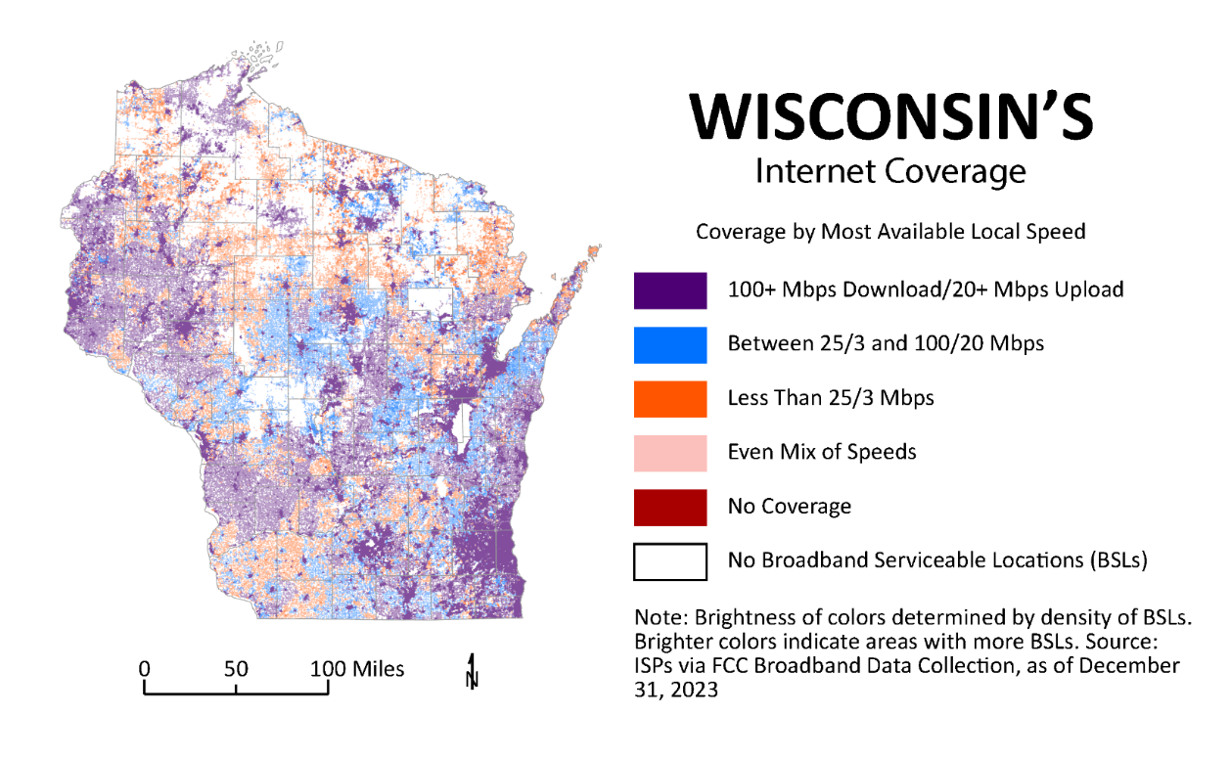

## AVAILABILITY BY TECHNOLOGY

The graph to the side shows the distribution of the approximately 8.7 million service offerings in Wisconsin among various technologies and BEAD speed definitions. A service offering is one internet service provider’s advertised service for a location. Some locations have multiple offerings, which results in approximately 8.7 million offerings across 2.3 million locations. In general, cable and fiber offer the highest speed service, while copper provides a mix of speeds under 100/20. Under the BEAD Program, unlicensed fixed wireless is considered unserved, regardless of speed.

The graphic below shows how these service offerings result in actual served locations using BEAD eligibility criteria and service reporting as of December 31, 2023. For locations with access to high-speed service of 100/20 or better (purple boxes), most all have service from a provider of fiber, cable, or both. Approximately 43,000 locations with 100/20 service lack fiber or cable and, instead, receive it from a copper or fixed wireless provider. For locations that are underserved with 25/3 to 100/20 service (blue boxes) and unserved with less than 25/3 service (orange), most service is provided by fixed wireless or copper providers. 1.3% of Wisconsin locations (red) lack access to any wired or fixed wireless technology of any speed. Across these technologies, basic internet access is available to most all Wisconsinites, although not all technologies provide speeds sufficient for the modern demands of entire households or growing businesses.

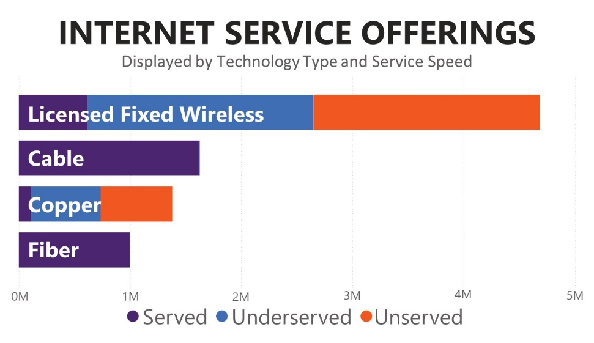

## SERVICE AVAILABILITY FOR 2,312,849 WISCONSIN LOCATIONS

## Chart illustrating Service Availability for 2,312,849 Wisconsin Locations

## CHANGE OVER TIME

Internet service providers report updated availability information to FCC every six months, providing a clear measurement of progress over time. During 2023, ongoing private investment and grant-funded construction produced approximately 180,000 additional locations able to access the internet from a fiber connection. Further, improvements to licensed fixed wireless technology, including deployment of additional licensed spectrum, new towers, and upgraded equipment resulted in approximately 240,000 additional locations being able to receive 100/20 service from a fixed wireless connection. Overall, approximately **88,500 more locations are “served” compared to the previous year**. The maps below show the areas of Wisconsin that now have access to 25/3 or 100/20 that did not one year ago.

The progress over the year is impressive, and it is clear that **public and private investments continue to close the gap in high need areas of Wisconsin**. However, gaps still exist, and FCC-based availability data remains incomplete in certain areas.

**WISCONSIN’S**

Changing Internet Landscape

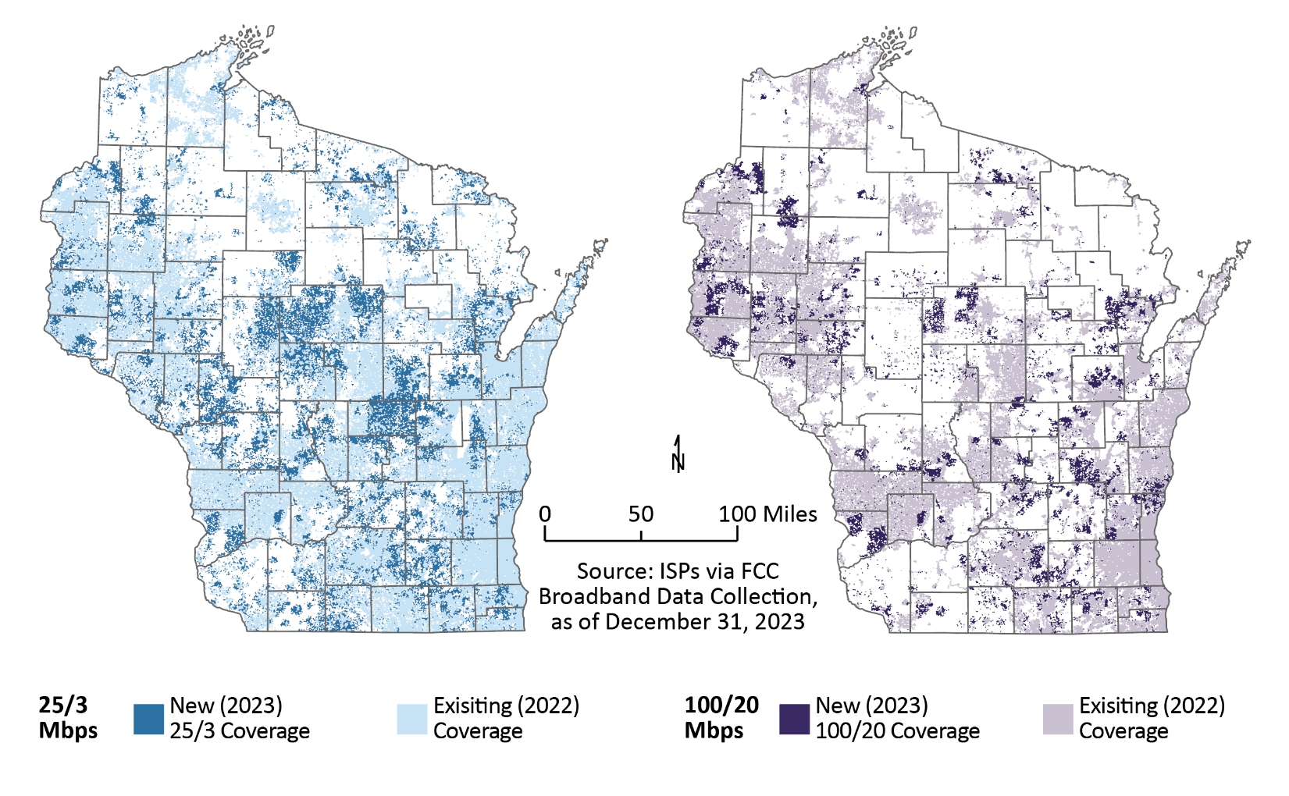

## BEAD Challenge Map

As part of the BEAD Program, NTIA requires the Wisconsin Broadband Office (WBO) to conduct a challenge process to determine whether a particular broadband serviceable location or community anchor institution is eligible for BEAD funding (i.e. unserved or underserved). [BEAD Volume One](https://apps.psc.wi.gov/ERF/ERFview/viewdoc.aspx?docid=496853) outlines that Challenge Process.

The challenge process has the additional benefit of further strengthening the accuracy of availability data. Through workshops, outreach, weekly office hours, engagement at local meetings, and informational publications, WBO engaged with local partners to utilize their knowledge of broadband availability to identify gaps and issues with existing advertised service data.

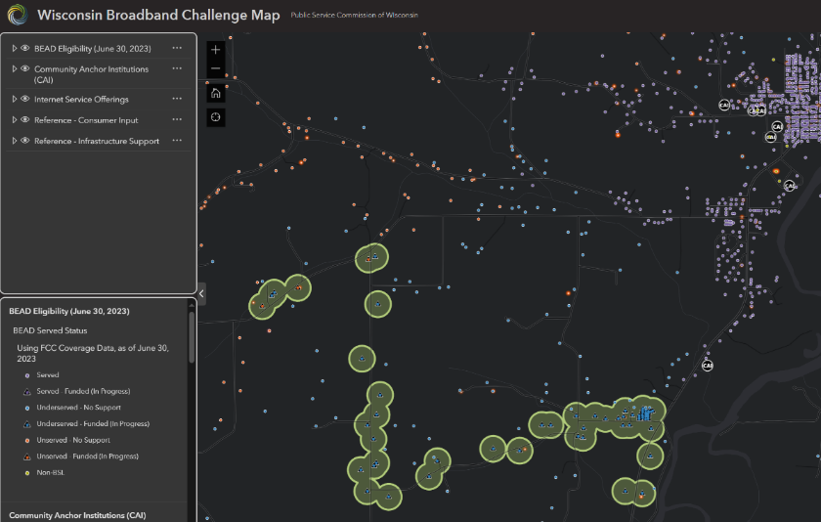

To conduct this challenge process, WBO created the [Wisconsin Broadband Challenge Map](https://maps.psc.wi.gov/portal/apps/experiencebuilder/experience/?id=ae28b4ce31fa44fb8366893c937d7c7f&page=home) to depict areas of Wisconsin likely eligible for BEAD funding. As part of the challenge process, eligible challengers reviewed data from the FCC and WBO on broadband service offerings, technologies deployed, and federal and state grant awards in progress to evaluate the accuracy of available data and suggest changes to improve data accuracy. Approximately 44,000 challenges resulted from this process through the end of the initial submission period on May 29, 2024. As of this report’s publication, the challenge process is ongoing, and the final result will improve data on where broadband deployment is needed and determine the eligibility of locations for BEAD funding.

## SUMMARY

Accurate mapping of broadband availability is a critical step to successful deployment of BEAD. The Task Force continues to see improvements to location-level reporting of broadband service after four iterations of the National Broadband Map. Further, continued private and public investment are having an immediate and overwhelming impact on the pace of deployment in Wisconsin as seen in the year-over-year improvements in broadband service. As Wisconsin begins to implement the BEAD Program, accurate maps informed by the BEAD Challenge process will ensure funding is strategically targeted and effective at improving service for those with the highest need.

# CURRENT STATE OF DIGITAL EQUITY

Access alone is not enough to guarantee a fair digital playing field in Wisconsin. WBO strives to achieve “digital equity” in the state, meaning every resident would have the necessary resources needed to participate in digital society. To achieve digital equity, WBO hopes to make the internet more affordable, provide internet enabled devices and digital literacy training, and technical support. WBO lays out its vision for digital equity in the [Wisconsin Digital Equity Plan](https://psc.wi.gov/Documents/broadband/WisconsinDigitalEquityPlanApproved.pdf).

## AFFORDABILITY

Cost is a significant barrier to internet adoption. The [Pew Research Center](https://www.pewresearch.org/internet/wp-content/uploads/sites/9/2021/06/PI_2021.06.03_Mobile-Broadband_FINAL.pdf) found that 45% of people cite the high monthly cost of a connection as the reason they do not have broadband. The cost of service was among the top five concerns indicated by Wisconsin residents during the Internet for All Wisconsin Listening Tour. Affordability issues are especially significant in rural areas, where on average the lowest priced available broadband subscription option is 15 percent higher than in urban areas, as seen in the adjoining chart.

Using the State median monthly income and establishing the reasonable cost threshold of 1.17% of monthly gross income, about 65% of unsubscribed households are cost-burdened, meaning their minimum monthly subscription costs exceed 1.17% of their gross monthly income. The map to the left shows how this cost burden is distributed geographically. While the average broadband service plan trends downward based on population density, the actual cost burden as a percentage of income tells a somewhat different story, with both urban and rural counties facing significant cost burdens for the average customer.

Through the BIL, the FCC was tasked with designing and implementing the Affordable Connectivity Program (ACP). The ACP provided a discount of $30 a month toward internet service for eligible households and up to $75 per month for households on qualifying Tribal lands. Eligible households included those with incomes below 200 percent of the federal poverty guideline, or participants in certain federal assistance programs such as SNAP, Medicaid, or public housing assistance, among others. Of the estimated 875,000 eligible households in Wisconsin, 426,733 of those households (one in six Wisconsin households) were enrolled in the ACP while it was active. Without additional funding from Congress, the $14.2 billion Congress originally made available to fund the ACP ran out at the end of May 2024. At the time of publishing, no additional funds for the ACP have been authorized and no successor program has been enacted despite advocacy from PSC Chairperson Strand and Governor Evers to Congress, although, several funding packages and bills to appropriate additional funds for the program have been proposed in Congress.

Both the FCC’s Lifeline Program and PSC’s complimentary State [Lifeline Program](https://psc.wi.gov/Pages/ServiceType/Telecom/LifelineForProviders.aspx), which helps to lower the monthly cost of phone and/or internet service, still exist. Households qualify for Lifeline if the household income is up to 135% of the federal poverty guidelines or if someone in the household participates in certain federal assistance programs like SNAP and Medicaid. In Wisconsin, approximately 114,000 households participate in the Lifeline program.

The BEAD Program takes important steps towards ensuring internet is affordable for residents statewide. Wisconsin’s draft BEAD Initial Proposal Volume 2 incorporates affordability into its scoring, including consideration of middle-class affordability and a requirement that broadband networks built or improved with BEAD funding must offer a low-cost plan to eligible households. In the draft Initial Proposal, BEAD project proposals will receive more points if they propose to improve affordability to ensure all Wisconsin residents have access to affordable, reliable high-speed internet.

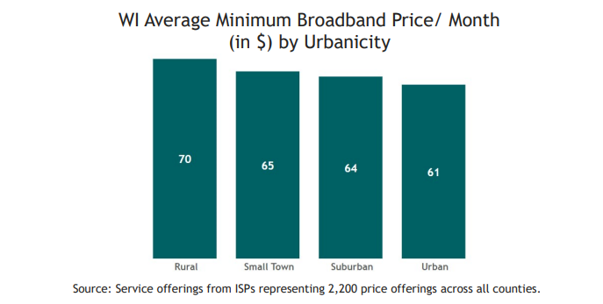

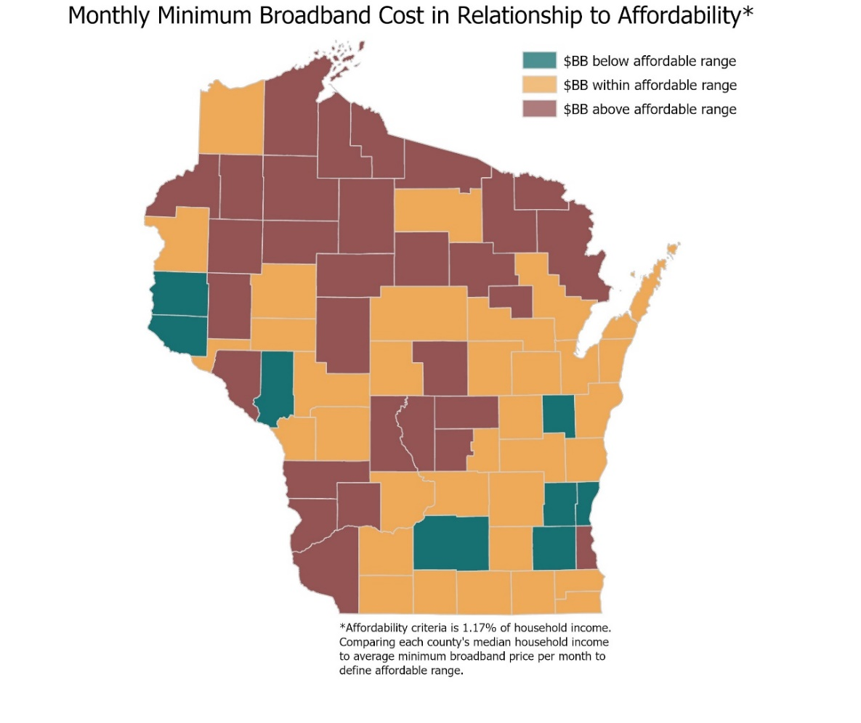

## ADOPTION

Broadband adoption is a vital aspect of achieving digital equity. Broadband adoption is when resident can connect to the internet with appropriate devices, skills, and information specific to their needs in real time. The broadband adoption gap exists, in part due to people choosing not to subscribe to internet services even with internet access available in their area. There are also instances where the broadband infrastructure fails to meet users’ requirements. Research has shown that affordability, digital readiness, and perceived relevance are the primary causes of the adoption gap in the United States.

2022 data from the [Computer and Internet Use Survey](https://www.census.gov/acs/www/about/why-we-ask-each-question/computer/), conducted by the U.S. Census Bureau, sheds light on current trends. National internet adoption rates have continued to rise, with 88.3% of households having a broadband internet subscription. In Wisconsin, the adoption rate stands at 87.7%, slightly below the national average. Further, Wisconsin lags the national average for households with a computer, at 92.9% in Wisconsin compared to 94.0% nationally. Despite progress, disparities in internet adoption persist both nationally and within Wisconsin. Notably, younger individuals exhibit higher rates of internet adoption compared to older adults, and those with college degrees have higher adoption rates compared to those with only a high school diploma.

**DIGITAL EQUITY OUTREACH GRANTS**

On April 21, 2023, the Commission, following a competitive grant application process, awarded a total of $335,000 in [Digital Equity Outreach Grants](https://psc.wi.gov/Pages/ServiceType/Broadband/GrantDigitalEquityOutreach.aspx) to seven nonprofit organizations around the state to conduct digital equity outreach, with members of the covered populations, to support the development of the Wisconsin Digital Equity Plan. Between them, over the course of six months, the subrecipients conducted 124 outreach activities, including focus groups, surveys in multiple formats and languages, 1-on-1 interviews, and town hall-style listening sessions. Through their outreach, the seven subrecipients heard from nearly 5,500 individuals and households across all eight covered populations.

Subrecipients’ outreach findings were aligned with the results of WBO’s own outreach activities and in support of Task Force recommendations. Subrecipients found internet subscription affordability, lack of digital skills, lack of trust (in organizations and government), and lack of access (to both quality, reliable internet service and affordable devices), and privacy/security concerns primary barriers to broadband adoption for all populations, with affordability being the primary, recurrent barrier.

Each subrecipient also identified population and community specific solutions to the identified barriers, along with valuable quantitative data and a wealth of qualitative data and anecdotes from members of the covered populations. Proposed solutions include increasing ISP competition to drive down service costs, increased availability of local digital skills and technical support, sponsoring the formation of public-private partnerships and coalitions to help coordinate and grow resources, device distribution programs, community education programs for privacy/cybersecurity and digital skills, entry level internet subscription offerings, internet subscription subsidies, and increased workforce capacity to improve access.

**WISCONSIN DIGITAL EQUITY PLAN**

Over a fifteen-month period, the Wisconsin Broadband Office engaged with over 184 stakeholder groups and collected data to draft and develop the Wisconsin Digital Equity Plan. Aligned and coordinated with the BEAD plan, the Digital Equity Plan sets an ambitious vision to ensure that all Wisconsinites have equitable access to affordable broadband service and the capacity to fully engage in a digital society. The mission coalesces around five core values that capture the many pieces that are needed to achieve true digital equity across the state. The five core values that frame the plan are:

**Access:** *Expanding high speed internet access to every residence, business, and institution in the state.*

**Affordability**: *Ensuring broadband and key digital services are affordable for all.*

**Adoption**: *Ensuring all residents can connect to the internet, with the appropriate accessible, internet-enabled devices, skills, information, and services specific to their needs in real time.*

**Trust**: *Providing readily accessible resources and supports to build trust with communities and ensure all feel safe when accessing the internet.*

**Sustainability**: *Supporting intentional activities and investments for ongoing device access, digital skills education, and affordable broadband subscriptions.*

For each of these values, the plan includes targeted goals, objectives, strategies, and metrics to address specific digital equity gaps in Wisconsin. This includes both short-term and long-term goals that are adaptable, knowing that digital equity needs are ongoing and evolving.

The plan went out for public comment in September of 2023, and was approved by the Commission to submit to NTIA in October of 2023. NTIA accepted the [Wisconsin Digital Equity Plan](https://psc.wi.gov/Documents/broadband/WisconsinDigitalEquityPlanApproved.pdf) on March 7, 2024.

The Digital Equity Plan serves as the foundation and pre-qualification for the state to receive Digital Equity Capacity Grant funding to implement several key activities from the Digital Equity Plan. In the first of what is expected to be three rounds of funding, Wisconsin has been allocated $13.2 million. PSC staff applied for the Digital Equity Capacity Grant funding on May 24, 2024, and the application is currently in the review process.

# IN PROGRESS: STATE AND FEDERAL FUNDING FOR INFRASTRUCTURE, ADOPTION, & EQUITY

In the past year, WBO transitioned from planning to implementing key federal programs under the BIL’s Internet for All efforts and the American Rescue Plan Act’s (ARPA) Capital Projects Fund Programs. Implementation of these programs, as well as continuing changes with other federal programming, offers numerous opportunities to supplement state-administered broadband deployment efforts.

## IMPACT OF PUBLIC FUNDING

Vastly improved data reporting from the federal government in 2023 shows the full extent of federally supported infrastructure deployment progress under the FCC’s new [Broadband Funding Map](https://fundingmap.fcc.gov/home). Combined with state data under its [Broadband Grant Footprint](https://maps.psc.wi.gov/portal/apps/experiencebuilder/template/?id=17311b111c9b4998a943b7ec7220c1bb&page=page_6), the map shows over 200,000 locations in Wisconsin that are not yet served but “in progress” under state, local, or federal funding commitments. While these locations remain in need of improved service and are included in the approximately 375,000 locations that are unserved and underserved, already committed funding means they will soon see that improved service. The accelerating deployment progress across Wisconsin is undoubtedly driven by significant state and federal investments in broadband grants in recent years. The map below shows locations that are “in progress” to build internet of at least 100/20 Mbps speeds under a state, local or federally funded grant and not already served as of June 30 of last year.

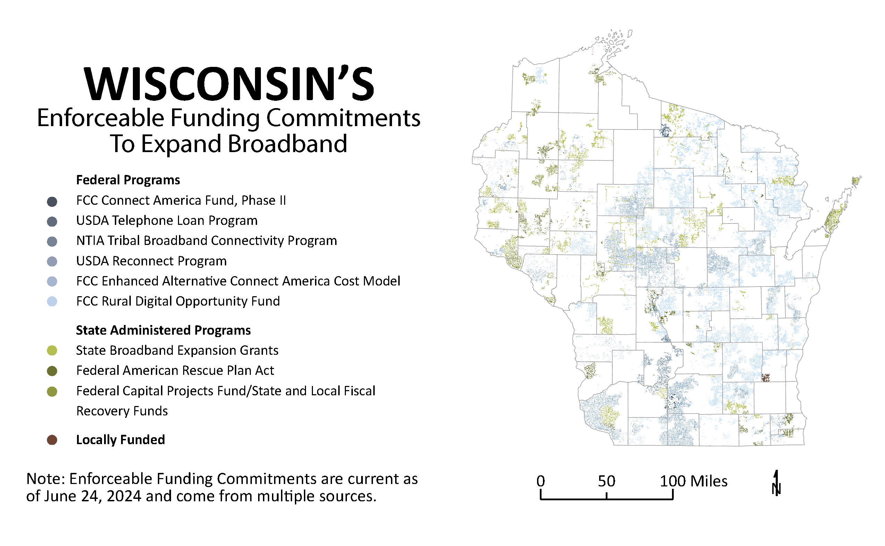

## BROADBAND EQUITY, ACCESS & DEPLOYMENT PROGRAM

On June 26, 2023, NTIA announced Wisconsin’s allocation of $1,055,823,573.71 BEAD implementation funding to support the deployment of broadband infrastructure. An early distribution of $5 million of this funding was used to support the data collection, outreach, capacity building, and planning efforts underlying the development of the [5 Year Action Plan](https://psc.wi.gov/Documents/broadband/5YearActionPlan.pdf) for BEAD deployment, and the subsequent Initial Proposal.

In 2023, the Commission and its partners conducted outreach and engagement initiatives with stakeholders, undertaking several streams of data collection and analysis, and drafted the necessary plans to ensure Wisconsin has both an accurate understanding of need and a comprehensive and equitable plan for implementing the state’s BEAD Program.

The Commission has partnered with UW-Extension and the Wisconsin Economic Development Corporation’s Office of Rural Prosperity to provide technical assistance workshops to local government and Regional Economic Development Organizations. In fall 2023 and spring 2024, UW-Extension offered two rounds of regional broadband [workshops](https://economicdevelopment.extension.wisc.edu/2024/02/14/spring-2024-broadband-regional-workshops-agenda-and-registration/), with over 400 total attendees, including local elected officials, economic development and planning professionals, internet service providers, members of the public, and other local partners.

In 2024, WBO will begin administering the grant allocation process of BEAD to identify recipients to build approximately 200,000 locations worth of fiber, fixed wireless, and satellite infrastructure. When looking at the BEAD Program, the Task Force expressed a strong preference for fiber technology to be the primary infrastructure deployed to meet the needs of Wisconsinites. Fiber provides a sustainable and ‘future-proof’ technology. However, the Task Force noted the value of fixed wireless solutions for the hardest to reach areas.

WBO intends to allocate the $1.06 billion in BEAD funding for infrastructure deployment during the allocation process that are expected to begin in fall 2024. After allocations are finalized and approved by NTIA, including required environmental reviews, it is expected construction will begin in late 2025 to early 2026, lasting until 2029-2030.

## DIGITAL EQUITY PROGRAMS AND PLAN IMPLEMENTATION

In 2024, Wisconsin will build off the Digital Equity Plan to administer future federal Digital Equity funding. WBO has submitted a proposal to NTIA to receive $13.2 million in Digital Equity Capacity funding to implement its parts of the Wisconsin Digital Equity Plan. At the time of publication, NTIA is in the process of reviewing that proposal, with approvals expected in fall 2024. WBO’s goals for Digital Equity work will be accomplished through its strong partnerships, including those with other state agencies, UW Extension, and others. Pending NTIA approval, WBO plans to implement the Plan using various strategies, including funding local coalitions, adopting a digital navigator training program, and funding digital navigators. WBO recognizes that digital equity is an evolving area and will continue to work with its partners to implement the Plan accordingly.

## STATE BROADBAND EXPANSION GRANT AND ARPA BROADBAND ACCESS GRANT

While no additional state funding was allocated for the State Broadband Expansion Grant Program in the Wisconsin 2023-2025 biennial budget despite a data-informed request of $750 million one-time funding in Governor Evers’ budget proposal, construction progress for existing state grants continues at a brisk pace. Since July 1, 2023, through June 14, 2024, 50 projects representing $33.4 million in grant awards have closed under the State Broadband Expansion Grant Program and the ARPA Broadband Access Grant Program, created by Governor Evers in 2021 with a $100 million investment of federal funds. These completed projects have impacted approximately 14,500 locations. As federal funding steps to the forefront in broadband infrastructure deployment, state funds continue to form a critical foundation to the long-term success of broadband expansion in Wisconsin. State funding proves a reliable and critical role in filling gaps to ensure Wisconsinites are not being left behind. As the 2025-2027 state budget process begins, the Task Force continues to strongly recommend additional state funding for broadband expansion efforts to ensure robust, timely deployment of needed broadband infrastructure and to meet the state’s ambitious goals of getting all Wisconsinites connected to high-speed broadband service in this decade. The Task Force sees state funding as critical to fill gaps caused by defaults and to upgrade the deployment of short-term infrastructure to ensure high-speed, future proof internet for all Wisconsinites.

## CAPITAL PROJECTS FUND BROADBAND INFRASTRUCTURE

The Commission continues to see robust demand for broadband infrastructure grants. Utilizing federal funding allocated under the Capital Projects Fund Program administered by the U.S. Department of Treasury, the Commission opened applications in August 2023 for its [Capital Projects Fund Broadband Infrastructure Program](https://psc.wi.gov/Pages/ServiceType/Broadband/CPFInfrastructure.aspx). The Commission received 124 applications requesting $221.6 million, the highest ratio of requested funds to available funds since the first state broadband grant round in 2014.

On March 7, 2024, the Commission awarded grants to [30 broadband infrastructure projects](https://psc.wi.gov/Documents/broadband/RptGrantSummary_CPF.2023.pdf), totaling $43.2 million that will provide new fiber internet service to over 16,000 homes and businesses in Wisconsin. Projects are underway and construction will continue through 2026.

## CAPITAL PROJECTS FUND DIGITAL CONNECTIVITY AND NAVIGATORS PROGRAM

The Commission is administering up to $33 million in federal funds through the Capital Projects Fund Program to promote digital connectivity by deploying computing devices, such as computers, laptops, and tablets, for eligible households to access. The program also promotes digital connectivity through the installation of Wi-Fi equipment in eligible multi-dwelling unit buildings, which includes apartment buildings, condominiums, and mobile home parks. Both approaches will include the provision of digital navigation services to ensure Wisconsinites can make full use of the internet for work, education, health monitoring, and other essential activities. This is the largest allocation of adoption-focused funding to date in Wisconsin.

On April 2, 2024, the Commission opened applications for the [CPF Digital Connectivity and Navigators Program](https://psc.wi.gov/Pages/ServiceType/Broadband/DigitalConnectivityNavigators.aspx), a competitive sub-grant program. The program will prioritize funding towards low-income, underserved, and underconnected communities that were disproportionately affected by the COVID-19 pandemic and continue to be at higher risk for future disaster due to lack of access to critical services. Applications are due July 3, 2024. Grants are anticipated to be awarded by the end of 2024.

## RURAL DIGITAL OPPORTUNITY FUND (RDOF)

The FCC administers the [RDOF program](https://www.fcc.gov/auction/904). The FCC made eligible census blocks that lacked service of at least 25/3 Mbps. In 2020, FCC operated a reverse auction mechanism and in Wisconsin 240,546 locations were assigned $373,715,051 in support over 10 years. After the reverse auction was complete and bids were assigned, winning bidders were to complete a long-form application process. All authorized RDOF recipients in Wisconsin will build infrastructure in the gigabit service tier.

Within Wisconsin, a handful of RDOF recipients defaulted on relatively minor portions of their award, including Wood County Telephone Company d/b/a Solarus and Pierce Pepin Cooperative Services. Further, as part of the long-form application process, LTD Broadband was ultimately not authorized for funding by FCC and thus defaulted on $189.3 million and 88,070 locations. On May 1, 2024, Charter Fiberlink CCO, LLC defaulted on an estimated 11,101 locations of their RDOF commitment. For further details, please see the [WBO’s notice on the default](https://intranet/ERF/ERFview/viewdoc.aspx?docid=501571). The PSC is aware of other pending defaults that have not yet been accepted by the FCC but could remove thousands of additional locations from RDOF build plans.

Defaults in the RDOF program represent a significant risk to ongoing deployment efforts, and further complicate the effort to deploy internet to all Wisconsin homes and businesses. Depending on the timing of these defaults, locations may not be eligible for BEAD funding, and may be left behind unless additional state funding is made available for broadband expansion.

Of the remaining approximately 136,811 locations with an RDOF commitment, gigabit service has been deployed to 36,495 locations as of December 31, 2023. RDOF projects must be fully deployed by December 31, 2028 at the latest.

|  |  |  |
| --- | --- | --- |
| **Provider** | **Total Obligation** | **Locations Deployed** |
| Amery Telcom, Inc. | 1,208 | 277 |
| Baldwin Telecom | 15 | 15 |
| Bruce Telephone Company, Inc. | 32 | 32 |
| Charter Fiberlink CCO, LLC1 | 129,137 | 32,210 |
| La Valle Tel Coop | 471 | 570 |
| Lakeland Communications, Inc. | 550 | 553 |
| Marquette-Adams Telephone Cooperative, Inc. | 66 | 22 |
| Reedsburg Utility Commission | 4,488 | 1,552 |
| Richland-Grant Coop | 844 | 1,264 |
| Total | 136,811 | 36,495 |

Source: [Connect America Fund Broadband Map](https://data.usac.org/publicreports/caf-map/) as of December 31, 2023

(1) Adjusted to reflect May 2024 default.

## ENHANCED ALTERNATIVE CONNECT AMERICA COST MODEL (E-ACAM)

On August 30, 2023, the FCC announced offers of a revised version of the Alternative Connect America Cost Model (“A-CAM”) to all rural rate-of-return providers, including A-CAM recipients. E-ACAM offers additional funding for reaching speeds of 100/20 Mbps, versus the 25/5 Mbps required by the original A-CAM. Providers participating in E-ACAM must complete deployment of their upgrades by December 31, 2028. Of the 33 rural rate-of-return providers offered to participate in E-ACAM in Wisconsin, 22 opted in participate for a total of approximately 243,682 locations covered by E-ACAM commitments that will now be built to 100/20 Mbps. All providers in Wisconsin have committed to deploy their E-ACAM commitments using fiber. A summary of committed locations by provider is shown in the table below.

|  |  |
| --- | --- |
| **Provider** | **Location Count** |
| Amery Telcom, Inc. | 9,297 |
| Amherst Telephone Company | 11,608 |
| Baldwin Telecom, Inc. | 3,845 |
| Bloomer Telephone Company | 3,113 |
| Bruce Telephone Company, Inc. | 2,234 |
| Clear Lake Telephone Company, Inc. | 1,507 |
| Coon Valley Farmers Telephone Company | 2,495 |
| Farmers Independent Telephone Company | 3,366 |
| Hillsboro Telephone Company, Inc. | 1,899 |
| LICT Corporation | 13 |
| LICT Corporation | 3,058 |
| Lakeland Communications, Inc. | 5,764 |
| Mount Horeb Telephone Company | 4,322 |
| Nelson Telephone Cooperative | 4,317 |
| Richland-Grant Telephone Cooperative, Inc. | 3,209 |
| Rural Communications Holding Corporation | 5,493 |
| Siren Telephone Company, Inc. | 2,547 |
| Spring Valley Telephone Company, Inc. | 1,051 |
| Telephone & Data Systems (TDS) | 133,715 |
| Tri-County Communications Cooperative, Inc. | 4,914 |
| Vernon Telephone Cooperative, Inc. | 8,140 |
| Wittenberg Telephone Company | 2,554 |
| Wood County Telephone Company | 25,221 |
| **Total** | **243,682** |

Source: FCC [Broadband Funding Map](https://fundingmap.fcc.gov/home) and NTIA as of March 26, 2024

## U.S. DEPARTMENT OF AGRICULTURE RECONNECT LOAN AND GRANT PROGRAM

[The Re-Connect Loan and Grant Program](https://www.usda.gov/reconnect) is open to eligible applicants nationally for funding the costs of construction, improvement, or acquisition of facilities and equipment needed to provide broadband service in eligible rural areas. The program has provided [five rounds of funding to date](https://fundingmap.fcc.gov/funding-summary?zoom=6.32&vlon=-90.938669&vlat=44.176981&speed=1&tech=1_2_3_4_5_6_7_8&agency=3&locs=0_811782&program=6&start=2019-01-31_2024-08-01&end=2022-12-09_2032-12-30), with two Wisconsin entities securing funding over the course of the program for fiber to the premises projects. Additional ReConnect awards are anticipated for fall of 2024.

|  |  |  |  |  |
| --- | --- | --- | --- | --- |
| **Provider** | **Funding Type** | **Funding Amount** | **Locations Planned** | **Project End Date** |
| Ntera | Grant (round 2) | $3,339,685 | 746 | May 2026 |
| Reedsburg Utility Commission | Loan (round 4) | $28,000,000 | 3,614 | December 2028 |

## TRIBAL BROADBAND DEPLOYMENT AND TRIBAL BROADBAND CONNECTIVITY PROGRAM

The Commission has also participated in important Tribal consultations to learn the vision, needs, concerns, and feedback of federally recognized Tribal Nations in Wisconsin regarding broadband. Tribal consultations ensure that Tribal sovereignty is respected throughout the implementation of WBO’s programs and that Tribal Nations have the capacity, support, and partnerships necessary to implement their vision for broadband deployment and digital equity within their communities.

Tribal Nations in Wisconsin have had significant success securing grants across PSC’s broadband expansion grants, as well as from the NTIA [Tribal Broadband Connectivity Program](https://broadbandusa.ntia.doc.gov/funding-programs/tribal-broadband-connectivity) (TBCP) and [US Treasury CPF for Tribal Governments](https://home.treasury.gov/policy-issues/coronavirus/assistance-for-state-local-and-tribal-governments/capital-projects-fund/cpf-fund-for-tribal-governments). The TBCP Program has made $3 billion of BIL funding available to federally recognized Tribes for broadband deployment and other critical needs, such as telehealth, distance learning, digital inclusion, and affordability. **With approximately $1.7 billion in funding committed to date, 10 of the 11 federally recognized Tribes in Wisconsin have received a Tribal Broadband Connectivity Award, totaling more than $37 million**, as seen in the table below. Under the Tribal CPF Program, 8 of 11 Tribes also allocated towards broadband the $167,504 each of Capital Projects Funds that they received, for a total additional tribal broadband investment totaling $1.34 million.

|  |  |
| --- | --- |
| **Federally Recognized Tribes located in Wisconsin** | **Tribal Broadband Connectivity Grant Awards** |
| Bad River Band of Lake Superior Chippewa Indians | $500,000 |
| Lac Courte Oreilles Band of Lake Superior Chippewa | $442,734 |
| Lac du Flambeau Band of Lake Superior Chippewa | $25,660,167 |
| Menominee Indian Tribe of Wisconsin | $500,000 |
| Red Cliff Band of Lake Superior Chippewa | $8,047,002 |
| St. Croix Chippewa Indians of Wisconsin | $302,032 |
| Forest County Potawatomi Community | $125,232 |
| Oneida Nation | $498,217 |
| Sokaogon Chippewa Community, Mole Lake Band of Lake Superior Chippewa | $452,162 |
| Stockbridge-Munsee Band of Mohican Indians | $499,571 |
| **Total** | **$37,027,117** |

Remaining unserved or underserved locations on Tribal lands that are eligible for BEAD and TBCP funding. While many Tribal Nations have applied for and won allocations of Tribal Broadband Connectivity Program funding to support planning, adoption, and deployment efforts on Tribal lands, in some cases these funds are insufficient to fully serve all locations on a Tribe’s land. As the Commission continues to roll out the BEAD Program, it has continuously engaged with Tribal leaders by sharing the latest BEAD eligibility data and information on deployment progress of other programs affecting Tribal lands. Tribal leaders ultimately determine if they wish to participate in BEAD, but BEAD funding is available to deploy broadband to fill gaps in remaining unserved and underserved Tribal locations.

# PROGRESS UPDATE: RECOMMENDATIONS FROM PRIOR YEARS

The 2024 Task Force Report echoes all previous three reports, building upon the work and success of previous reports. It is key to remember this when looking at the year-to-year work of the Task Force. As such, the Task Force believes previous years recommendations and themes are still pertinent today and will continue to revisit, revise, and track the Task Force’s goals and progress as needed.

## PERMITTING COORDINATION AND RIGHT OF WAY ACCESS

In preparation for BEAD, the Task Force heavily discussed the 2021 and 2022 goal: **increase construction and permitting coordination.** The following progress has been made to improve permitting coordination and access to right of ways:

* The Wisconsin Department of Transportation (DOT) hired a State Broadband Coordinator to focus on broadband projects involving DOT right of ways.
* The Commission continues to coordinate with the Wisconsin Department of Natural Resources (DNR) to share resources and information in advance of BEAD.
* In March 2024, NTIA launched the [Permitting and Environmental Mapping Tool](https://www.internetforall.gov/news-media/ntia-launches-permitting-and-environmental-mapping-tool) to help grant recipients and others deploying infrastructure identify permit requirements and avoid potential environmental impacts when connecting a particular location to high-speed Internet service.
* The Advisory Council on Historic Preservation (ACHP) and NTIA [are simplifying](https://www.ntia.gov/blog/2024/expanding-internet-access-and-protecting-historic-properties) National Historic Preservation Act reviews related to BEAD deployment in instances where a project area: has previously been surveyed and not found to contain historic properties, has been previously disturbed to the extent and depth where the probability of finding intact historic properties is low, is not considered to have a high probability for historic properties by qualified professionals, or meets certain other exemptions.
* On April 2, 2024, NTIA released [two notices](https://www.federalregister.gov/documents/2024/04/02/2024-06748/adoption-of-first-responder-network-authority-categorical-exclusions-under-the-national) for 36 new categorical exclusions (CE) to expedite the National Environmental Policy Act (NEPA) review process for BEAD deployment with minimal potential for environmental effects. CEs are categories of actions that a federal agency has determined, after review by the Council on Environmental Quality (CEQ), do not individually or cumulatively have a significant effect on the human environment and therefore typically require neither an environmental assessment nor an environmental impact statement.
* The PSC [Broadband Forward!](https://psc.wi.gov/Pages/ServiceType/Broadband/BroadbandForward.aspx) certificates continue to support local legislation and local ordinances passed to streamline administrative procedures, adhere to a timely approval process, charge only reasonable fees for reviewing applications and issuing permits, and imposing only reasonable conditions on a permit. Five Broadband Forward! Certifications were issued this past year, bringing the total amount of Broadband Forward! Certification to 88 communities.

## BROADBAND CONSUMER PROTECTIONS

In 2021 and 2022, the Task Force recommended **increasing broadband consumer protections and pricing transparency by creating standard labeling disclosure for broadband services that would include monthly changes for date, other charges, additional fees, network performance, privacy info, contract term, and complaint contact info**. While Governor Evers included multiple new provisions to protect broadband consumers and ensure high-quality, reliable broadband service in his 2023-25 state budget proposal, these provisions were rejected by the state Legislature. This year, FCC announced its deadline for providers to start displaying [Broadband Consumer Labels](https://www.fcc.gov/broadbandlabels), which have been likened to "nutrition labels" for broadband service. Large providers were required to start displaying labels on April 10, 2024. Those with 100,000 or fewer subscriber lines have until October 10, 2024. Labels must disclose information about broadband prices, introductory rates, data allowances, and broadband speeds, and links to information about network management practices and privacy policies.

Sample image of broadband label


## DATA AND MAPPING

In prior reports, the Task Force recommended **collecting internet access data from all ISPs at household and business levels of granularity and develop data dashboards of where state and federal funds have been spent, have been awarded, or could be spent**. Further, in 2023, the Task Force recommended **funding and supporting annual statewide mapping and data collection efforts (e.g. GEO software, Wisconsin Internet Self Report, Department of Public Instruction Digital Equity Surveys) that support stakeholder networks, physical infrastructure networking, and overall broadband planning efforts.** Broadband service data collection continues to improve significantly, and the [FCC National Broadband Map](https://broadbandmap.fcc.gov/location-summary) version four (as of December 31, 2023) was recently released.

Further, in fall of 2023, WBO received its first deliverables as part of the Broadband Intelligence Project. The Broadband Intelligence Project recruited specialized contractors to collect, analyze, and summarize data on access, affordability, and adoption for Wisconsin residents. The data informed WBO design and implementation of its BEAD and DE programs, and continues to demonstrate the significant cost burden of broadband in certain areas of the state. Further, Broadband Intelligence provided valuable data on the barriers to adoption across Wisconsin. Broadband Intelligence data will ensure data-driven decision making during the BEAD allocation process that ensures prudent investment that maximizes the impact of WBO’s BEAD allocation.

In fall 2023, WBO published its [County Profiles](https://psc.wi.gov/Pages/ServiceType/Broadband/CountySummaryData.aspx) that has compiled data from all 72 Wisconsin counties to create county specific summaries of broadband access, internet service providers, affordability, and deployment progress. The profiles highlight the total number of residential and business locations in each county by current advertised service offering category. The profiles also include a count of locations that have existing state or federally funded grants in progress, speed tests by county, and affordability analysis based on median county income and county specific broadband price data. A [state summary](https://psc.wi.gov/documents/broadband/CountyProfiles/Statewide.pdf) was also created.

The [Wisconsin Broadband Planning Map](https://maps.psc.wi.gov/apps/WisconsinBroadbandPlanningMap/) continues to be updated as a critical tool for understanding BEAD eligibility, previous broadband funding, and user experience data. The PSC Wisconsin Internet Self Report ([WISER](https://maps.psc.wi.gov/apps/WISER/index.html)) continues to be available to the public and has collected over 10,000 responses with vital data regarding Wisconsin households and businesses access, cost, and adoption information. Beginning in 2024, WBO also created the [BEAD Challenge Map](https://maps.psc.wi.gov/portal/apps/experiencebuilder/experience/?id=ae28b4ce31fa44fb8366893c937d7c7f&page=home) to display eligibility data for each location, including its available service speeds and any in progress grant projects, as part of the upcoming BEAD program.

In summer 2023, UW-Extension in partnership with WBO, administered a statewide survey of all counties and federally recognized Tribes, and received responses from 70 of 72 counties and 6 out of 11 Tribes. The survey included questions on broadband access, planning, affordability, and adoption efforts and was used to inform the Digital Equity Plan and Five-Year Action Plan.

## DIGITAL EQUITY AND AFFORDABILITY

In 2021, the Task Force recommended to **establish a statewide digital equity fund operated by a nonprofit or similar organization with a mission to fund, strengthen and support digital inclusion activities and ideas that lead to all WI residents having the information capacity needed to fully participate in society.** While no state funding has been allocated thus far, significant federal investments have targeted these needs in recent years. In 2023-24, Wisconsin administered its State Digital Equity Planning Grant funding and has submitted a Digital Equity Plan to NTIA. NTIA approved the [Wisconsin Digital Equity Plan](https://apps.psc.wi.gov/ERF/ERFview/viewdoc.aspx?docid=493807) on March 7, 2024. Looking forward, PSC has applied for State Digital Equity Capacity Grant funding of $13,248,029 to implement its digital equity plan. The application is now pending approval with NTIA, and the Commission expects to begin subgrant funding rounds in the coming year.

In 2021 and 2023 the Task Force recommended to **establish a State Internet Assistance Program**. At the time of this recommendation, ACP was in progress and the Task Force recognized that a more permanent solution was necessary. In May 2024, ACP funds were depleted and as of the publication of this report,no action has been taken by Congress to provide additional funding for the program. The Task Force continues to recommend in this annual report to establish a state internet assistance program to increase broadband affordability and adoption. Data shows that low-income affordability programs increase adoption rates, making deployment more financially feasible by increasing the number of customers. It was discussed in numerous Task Force meetings that it would be hard to argue for a business case scenario to increase broadband expansion without increased adoption.

In 2021 and 2022 the Task Force recommended to **develop and fund a statewide Digital Navigator program to assist under-connected people and solve a wide range of adoption issues**. State funding for digital navigators has not been provided, despite Governor Evers proposing the creation of a state Digital Equity program and including digital navigation services as part of the program’s scope of work in his 2023-25 state budget proposal. However, using funding from the U.S. Department of Treasury’s Capital Projects Fund Programs, the PSC established the [Capital Projects Digital Connectivity and Navigators Program](https://psc.wi.gov/Pages/ServiceType/Broadband/DigitalConnectivityNavigators.aspx). The program will provide up to $33 million in funding to deploy computing devices and install Wi-Fi equipment in targeted apartment buildings, which will be paired with digital navigation services. The digital navigation services are an eligible cost under the program and will allow for participants to fully utilize the devices and equipment for work, education, and health monitoring.

## PLANNING, PARTNERSHIP, AND CAPACITY BUILDING

Previous task force reports have recommended to increase **pathways for community leaders and stakeholders to connect and network with ISPs and middle mile providers, including ISPs not currently serving the community**. From September 2023-October 2023 and March 2024-May 2024, the University of Wisconsin-Madison Division of Extension held broadband workshops around the state. These workshops were attended by local municipal and county government leaders, local broadband champions, and ISPs. The purpose of these workshops was to discuss and learn about state and federal broadband permitting, and BEAD engagement and endorsement between local government and tribes with the ISPs. There was panel presentations and discussions of public private partnerships, adoption resources, and local broadband planning projects.

The 2022 report recommended to **encourage and support coordination with Tribal entities in broadband planning, resources deployment, and funding experience, and unique needs, in their pursuit of digital equity and broadband deployment in their community**. There has been regular engagement with Tribal leaders through technical assistance and formal consultations by WBO on BEAD, Digital Equity, and State Expansion Grant awards. Tribes are eligible for BEAD funding for locations that remain unserved and underserved, and WBO continues to coordinate with Tribal leaders to inform them of BEAD implementation progress.

Developing capacity and educating practitioners to empower broadband planning and partnerships has been essential to the Task Force’s work. The 2022 and 2023 reports recommended to **create a ‘playbook’ or ‘how-to’ guide to assist communities and local leaders in broadband and Digital Equity planning efforts.** UW-Extension has invested significant energy providing technical assistance and a developing its [Broadband Toolkit,](https://economicdevelopment.extension.wisc.edu/broadband-toolkit/) which serves as a guide for communities to build local capacity. UW-Extension has also been hosting broadband planning webinars between February-August 2023, broadband workshops in September-October 2023, and hosted nine BEAD preparation workshops across the state from March-May 2024.

The 2023 task force report recommended that **fiber technology be prioritized, but not exclusively required in publicly funded broadband deployment. Terrestrial fixed wireless solutions are viable in particularly hard to reach areas and/or as a short-term solution**. In developing its BEAD implementation plan, the Commission emphasized this by prioritizing fiber in feasible areas and explicitly including fixed wireless solutions as eligible and targeted solutions in certain areas.

In 2023, the Task Force recommended **ensuring sufficient and trained telecom workforce for internet service providers, contractors, and subcontractors to construct, operate and maintain current and new broadband infrastructure. Where practicable and with input from higher education and employers, Wisconsin should encourage hiring from within local communities to help retain local talent and grow good jobs within Wisconsin**. During the past year, the Commission implemented its BEAD Workforce Planning Grant to evaluate workforce needs and identify best practices for workforce training. As part of the BEAD Initial Proposal, the Commission has proposed allocating funding for workforce training in partnership with the Wisconsin Technical College System.

# TASK FORCE RECOMMENDATIONS

## PREPARING FOR BEAD

Preparing for BEAD has been a focus of the Task Force. The Task Force provided guidance on the development of the [BEAD Five-Year Action Plan](https://psc.wi.gov/Documents/broadband/5YearActionPlan.pdf) that outlined goals and priorities for the State. The scale and complexity of the BEAD Program warrant additional focus for streamlining processes and resolving bottlenecks in capacity to ensure a prompt and effective implementation. As the Task Force evaluated preparations for BEAD, it found opportunities to improve permitting and locating, workforce opportunities, Tribal coordination, and grant administration.

This year, the Task Force heard a presentation from the Wisconsin Department of Transportation Broadband Permit Coordinator, and a locating presentation by Scott Nyman of Wittenberg Telephone Company. The Task Force discussed and learned about permitting and locating issues related to miscommunication, policy inconsistencies, labor shortages, and lack of accountability. In turn, the Task Force included permitting and locating recommendations to help address these issues proactively in lights of the tight BEAD implementation timelines.

In discussions around permitting, Task Force members heard about challenges related to crossing railroads, and the timely and accurate locating of underground facilities, as well as concerns related to costs to attach to utility-owned poles for aerial deployment and some permitting backlogs. In some cases, permitting delays have delayed construction until the subsequent building season and forced ISPs to seek extensions on grant projects. Further, providers are seeing a strain in capacity for locating services, which must be completed before they can begin construction. If a contractor crew arrives at a location for work and no locates have been completed, they must cancel their planned work and may lose several days of construction.

Permitting and locating delays are costly, making it difficult to schedule contractors and sequence deployment projects. These delays cause increased interest payments on debt financing, lost staff and contractor time, and delays in acquiring new customers. The Task Force recommends policy makers consider legislation or guidance that create firm and predictable timelines and reasonable and transparent costs.

Workforce development was another critical area of focus for the Task Force last year. With significant funding that has been injected into the telecommunications industry the past few years, and historical amount on the way, meeting the ever-increasing workforce demand has been and will continue to be a key challenge.

The Task Force deemed that it important that Wisconsin create a sustainable pipeline of talent and help aid in the connection of that pipeline to potential employers. Workforce development boards, economic development organizations, high schools, technical colleges, internet service providers, state agencies, and more will all play an important role in ensuring this pipeline is available and sustainable. Wisconsin must include all available workforce and make concerted efforts to engage veterans, formerly incarcerated individuals, individuals who are members of a racial or ethnic minority group, and more.

The Task Force also considered that it was important to promote jobs in the broadband sphere as a viable, meaningful, well-paying career. Increased awareness in areas like high schools will lead to more talent and dollars staying inside Wisconsin’s economy. Many internet service providers would prefer to hire local and train within their company. To do that, Wisconsin needs a local pipeline of talent and interest. Workforce development continues to be an ongoing area of emphasis as the state plans to administer the BEAD and DE programs. Considering and executing these recommendations will put Wisconsin in a better position to succeed with respect to workforce development in the telecommunications industry.

NTIA has delegated states to administer the BEAD Program. The PSC has been successfully administering broadband grants since 2014. With the timeline requirements of BEAD, the Task Force made grant administration recommendations to streamline processes and have the necessary human resource and technical support available for administering BEAD.

Tribal coordination is a recommendation that will play an important role in preparing for BEAD. The Task Force recognizes that the Tribal Nations of Wisconsin have their own sovereignty, have their own plans for equitable access to broadband, and have tailored needs for each unique Tribal Nation. There have been past issues of ISPs building or claiming to build on Tribal lands without the Tribes permission or permits, ISPs not wanting to build on Tribal lands because they find the process difficult, and inaccuracy of broadband service data on Tribal lands. The State of Wisconsin, ISPs, and local governments continue to work on transparency, communication, and collaboration with Tribal Nations. The Task Force voices that Tribal coordination is key in order to meet the requirements of the BEAD Program and achieve Internet for All Wisconsinites.

### CASE STUDY 1: Extension Workshops

The University of Wisconsin-Madison, Division of Extension, hosted broadband workshops delivering BEAD technical assistance. Thirteen regional workshops were conducted between September of 2023 and May of 2024. In total, there were over 400 participants from 56 of 72 counties, and an additional 11 counties represented by a regional planning commission and/or economic development organization. Additionally, the workshops were attended by 32 ISPs.

Several organizations supported the development of these workshops including the Wisconsin Broadband Office, Wisconsin Counties Association, League of Wisconsin Municipalities, Wisconsin Towns Association, WEDC Office of Rural Prosperity, and the Wisconsin State Telecommunications Association.

Fall workshop participants networked with each other and learned about the role of counties in broadband planning, updates on the BEAD timeline, how to use economic data for broadband planning, financing options, legal considerations for broadband projects, public-private partnerships, and each workshop concluded with public-private partnership meetings between public sector participants and internet service providers.

Spring participants learned about the BEAD subgranting and challenge process, NEPA, permitting considerations for broadband projects, engagement and endorsement, and examples of local broadband projects.

Materials from the workshops are available at [UW-Extension Broadband Toolkit](https://economicdevelopment.extension.wisc.edu/broadband-toolkit/) on the Workshops and Webinars page.

Photo: University of Wisconsin – Madison Division of Extension’s Community Economic Development logo.

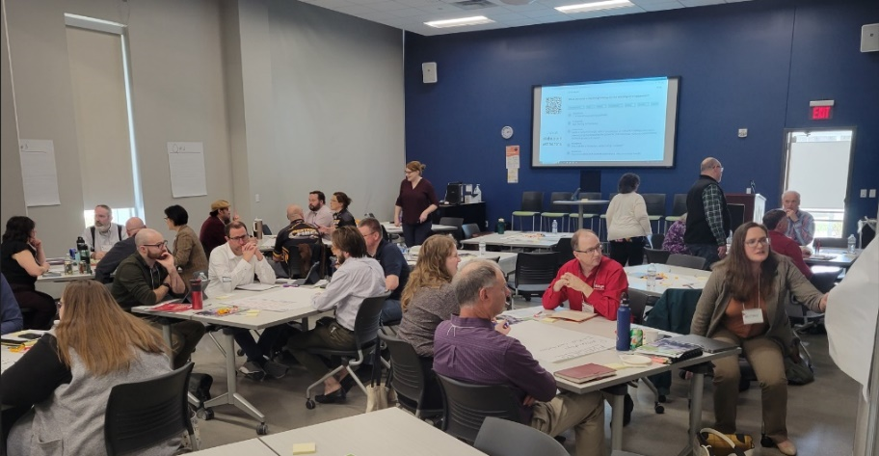

**PREPARING FOR BEAD RECOMMENDATIONS**

* Utility, Telecommunication and Broadband Facilities Locating
  + Increase the availability of design and engineering information for grant-funded broadband deployment projects to empower more efficient locating efforts during BEAD.
  + Establish a compliance system and monetary penalties to hold telecommunications utilities and internet service providers accountable for failure to complete locates within required time period.
  + Explore feasibility of requiring broadband deployment projects to pre-mark their planned construction route prior to requesting a facility locate to ensure expedited and accurate locating efforts.
  + Consider the establishment of a confidential clearinghouse that would share as-built data from ISPs on a limited basis to streamline locating and permitting.
* Permitting
  + Support permit planning and increase analysis of permitting needs by publishing and distributing guidance, maintaining web maps and tools to identify potential permitting jurisdictions, and providing technical assistance.
  + Increase permitting coordination by acting as a liaison and advocate between internet service providers and the federal government and advocating for and supporting efficient permitting compliance processes.
* Workforce/Training.
  + Allocate funding and state resources to support workforce training and credentialing programs to ensure a sufficient and trained workforce for internet service providers and contractors, to construct, operate and maintain current and new broadband infrastructure.
  + Through funding and technical assistance, support and include organizations such as workforce development boards, economic development organizations, labor groups and unions, contractors, high schools, higher education and technical colleges, and state agencies (DPI, DWD, PSC) in workforce planning efforts, youth apprenticeship opportunities, and retraining existing workers. Ensure that these organizations are being connected with internet service providers and telecommunications associations to increase awareness and create a sustainable and viable pipeline of talent.
  + Where practicable and with input from employers and higher education, incentivize hiring from within local communities to help retain local talent and grow good jobs within Wisconsin. Collaborate with local community organizations and educational entities to cultivate community engagement and establish a robust talent pipeline.
* Grant Administration
  + Continuously improve, implement, and streamline grant administration and compliance processes that ensure efficient, transparent, and accountable use of public funding.
  + Enhance processes to streamline reporting, reimbursement, contracting, and compliance processes to reduce the cost and burden on recipients of state and federal funds and ensure timely and accountable deployment of public funding for the largest public benefit.
  + Provide technical assistance to grantees related to meeting compliance and reporting requirements, and widely distribute informational materials and technical assistance opportunities.
* Tribal Coordination
  + Support Tribal Nations located in Wisconsin in their deployment efforts by providing technical assistance for participation in BEAD. WBO should work to ensure Tribal partners are aware of timelines and urgency of BEAD Program.
  + Encourage and support coordination with Tribal Nations considering and developing partnerships with neighboring local governments and internet service providers.
  + Collaborate with Tribal Nations to ensure consent is given for any grant funded project affecting Tribal lands and to ensure provider compliance with permitting and historic preservation requirements.

**CASE STUDY 2: New North - Internet for All Requires All to Collaborate**

The Commission funded the [BEAD Local Planning Grant](https://psc.wi.gov/Pages/ServiceType/Broadband/GrantLocalPlanning.aspx) knowing local knowledge, understanding, and outreach was imperative to guide the state’s overall Five-Year Action Plan with the ultimate goal of Internet for All. Local plans included outreach initiatives, conducting local needs assessment and developing local or regional broadband plans. Counties and Tribes were allocated funding and had the choice to participate in the grant on their own or collaborate in a Regional Economic Development Organization (REDO).

16 counties in the REDO region of the New North elected to work collaboratively and in doing so got a 10% increase in allocated BEAD Local Planning funds. The New North Broadband Alliance was formed and has been working collaboratively since February 2023. County representatives (Broadband Champions) have met monthly alongside New North, PSC-WBO, Neverman Consulting, and two regional plan commissions in the region – East Central Wisconsin and Bay-Lake to share knowledge and prepare for the release of BEAD grant applications.

[NEW North Broadband Equity Access and Deployment Hub](https://new-north-broadband-equity-access-and-deployment-hub-ecwrpc.hub.arcgis.com/) was created to house New North mapping tools to identify ISP providers in each of the 16 counties, track changes of BSL data, see trends in population data, and identify where fiber can be expanded for BEAD. The Hub also has links to resources to assist with broadband planning.

The Alliance’s mission is to provide all New North residents with access to high-speed internet service. Information sharing amongst the Alliance has been key to the success of BEAD Planning. The Alliance convened a readiness workshop using a draft of the rubric the PSC plans to use when awarding the BEAD dollars. Alliance Members also met with ISPs to discuss the best path forward to expanding broadband coverage and created detailed maps showing gaps in coverage.

The New North wants everyone involved to be as prepared as possible when the PSC announces Volume 2 of their BEAD Proposal is approved. Once the PSC receives approval, it has 365 days to award its grant dollars and we want as many of the residents in the New North region to be connected as possible.

The New North believe broadband is no longer a nice-to-have amenity, it’s a necessity. It is vital to the continued economic growth of the region and are committed to working collaboratively with our partners to get Internet for All in the New North.

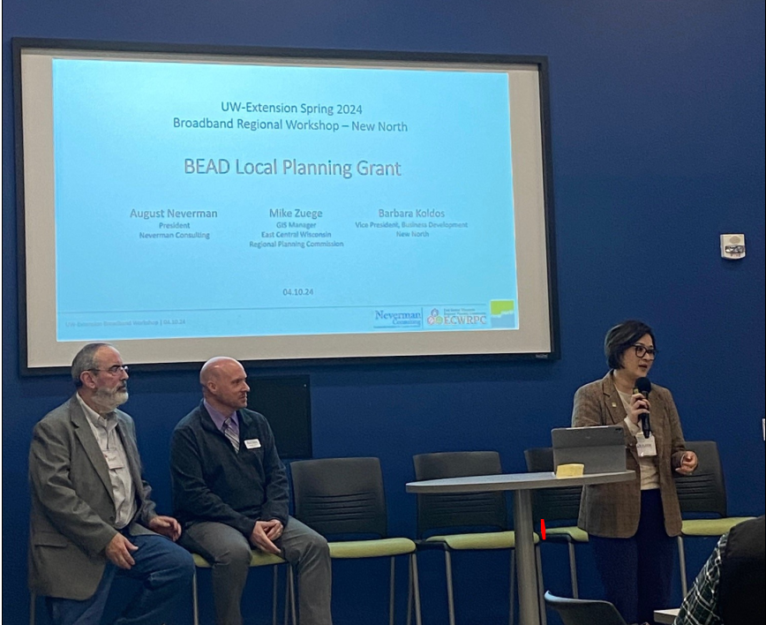

*The New North Broadband Alliance consists of representatives from Brown, Calumet, Door, Florence, Fond du Lac, Kewaunee, Manitowoc, Marinette, Marquette, Menominee, Oconto, Outagamie, Shawano, Waushara, Winnebago counties as well as East Central Wisconsin Regional Planning Commission, Bay-Lake Region Plan Commission, Neverman Consulting, PSC, and New North.*

### CASE STUDY 3: Ho-Chunk Nation

The Ho-Chunk Nation, spread across 14 counties in Wisconsin, with communities in Minnesota and Illinois, faced a significant challenge in connecting their Tribal Members to broadband services. The average broadband speed within their communities was at best 12/3 Mbps, averaging 7/3 Mbps, which was problematic for healthcare, distance learning, and telecommuting. The geographical dispersion of the communities and the need to navigate through multiple Internet Service Providers (ISPs) and counties made the situation more complex.

The Ho-Chunk Nation initiated a large-scale broadband project to address this issue. The project was complex due to the geographical dispersion. Ho-Chunk applied for and received a USDA Rural Placemaking Innovation Challenge Grant to fund broadband planning and community engagement. Ho-Chunk understood the importance of working on relationships with multiple layers of counties and municipalities, such as Jackson County and local townships. They started by contacting several counties, municipalities, and townships to discuss the core context of what needed to be accomplished.

The Ho-Chunk Nation established a minimum broadband speed of 1,000 Mbps synchronous as their minimum broadband standard. They also applied for a National Telecommunications and Information Administration (NTIA) Broadband Infrastructure Grant to deploy 76 miles of fiber in Eastern Jackson County. Ho-Chunk’s NTIA application is pending award notice.

Ho-Chunk has been successful due to advanced planning and the right team. They completed a year long series of community engagement sessions that provided broadband and digital literacy education to Ho-Chunk Members and Jackson County Residents. They partnered on a speed test and survey that included not only Ho-Chunk but the entire Jackson County population. One lesson learned was the importance of early engagement with senior tribal leadership and partnering jurisdictions to develop an understanding of the Bureau of Indian Affairs (BIA) processes associated with ISPs. ISPs are typically used to working with municipalities and counties, but there is another level of complexity when working with the BIA and the Department of the Interior.



## CONTINUED INVESTMENT OF STATE BROADBAND FUNDING

The Task Force affirms its previous recommendations for additional investment of state funding to expand broadband access to Wisconsinites. The Task Force heard from several presenters on this topic discussing prior grant awards and projects, and future needs.

The presenters demonstrated how critical state broadband funding was on successful broadband projects. The Task Force has also heard from residents that lack service, but their neighbors across the street or at the end of the road have access. WBO is all too familiar with hearing these stories.

BEAD will provide a once-in-a-generation funding source to address broadband connectivity. These dollars are critical for eligible entities to continue to reach homes and businesses that are the hardest and expensive to serve in the state. However, a strained supply chain stretches limited public investment even more thinly and threatens the ability to achieve the Task Force goals. While a complex and challenging issue, finding ways to combat supply chain and inflation issues was a large point of discussion for the Task Force.

The Task Force recognizes that BEAD will be a significant contribution to connecting Wisconsin residents, but that it remains the case that additional state funding will be needed to reach Internet for All. Recent defaults of federal funding awards, withdrawals of previously awarded state grant projects and the potential for future changes in funding commitments leaves risk that not all locations in Wisconsin will be connected without additional state funding. Further, the significant investment of BEAD will not be sufficient to deploy future proof fiber internet to all locations, and further state investments may be necessary to ensure high-speed, long-term reliable internet service for all.

**CONTINUED INVESTMENT IN STATE BROADBAND PROGRAMS RECOMMENDATIONS**

* Invest additional state budget funding for broadband expansion to address gaps left behind after BEAD process. Target state funding in areas where actual experienced speeds differ from advertised service due to aging and less-reliable technology, and where prior federal funding awards default and are left incomplete.
* Consider line extension funding to help bridge gaps in installation costs of broadband.
* Where feasible, strategically braid state broadband expansion funding with federal funds to build more locations with fiber and reduce BEAD’s reliance on less reliable technologies in more remote, less resourced areas of Wisconsin.

### CASE STUDY 4: Oneida County Partnership with Bug Tussel

In 2012, the Oneida County Board decided to delegate the Oneida County Economic Development Corporation (OCEDC) as their Technology Committee. The OCEDC has since been responsible for technology and broadband in Oneida County. In 2014, they began working with ISPs in the area applying jointly for grants from the PSC to improve broadband access. The county has received five PSC Broadband Expansion Grants over five years, which allowed them to build over 30 fixed wireless towers serving about 1,200 customers.

The OCEDC created a public-private partnership with the ISP Bug Tussel. The plan developed with Oneida County included a business model where the ISP would forward-fund three years’ worth of build-out, allowing them to gain subscriptions. To keep interest rates low, the counties had to guarantee bonds that the ISP would have to obtain, which has become a preferred model the ISP has been enacting in multiple counties. They would then pay for the infrastructure over the next 27 years through subscription fees. The project was further supported by a $2.7 million PSC grant.

The Oneida County Supervisors approved the project within the county boundaries in the fall of 2023. The project includes 225 miles of open access middle mile fiber backbone and 65 miles of final mile fiber hookups that will serve 6,000 to 10,000 residents depending on the take rate, six additional 300-foot cell towers to fill in gaps, dramatically improving first responder communication as well. The project also provides county-owned fiber to all township facilities. This was strategically put into place knowing BEAD funding was around the corner. In concept, the remaining locations not connected will be the focus, connecting them to the newly installed middle mile fiber. The final project is expected to result in 10,000 to 12,000 new customers for broadband by 2027-2028.

Public-private partnerships are challenging but necessary for such large-scale projects. Persistence is key in overcoming obstacles and securing approval for the project. It took over a year of education and consensus building to have the approval for the bond from the Oneida County Board to come through. It’s important to keep scanning the landscape for changes and adapt the project accordingly. The partnership was surprisingly smooth, and the project design process went well. The challenge was getting all the individual opinions on board and approving the project. Education is crucial in this process to address questions and concerns.



## AFFORDABILITY AND ADOPTION

The fact that access to broadband infrastructure alone is not enough for Wisconsin residents and communities to realize the digital opportunity benefits from broadband has been a significant point of discussion for the Task Force for many years. Access to *affordable* broadband service is critical to a more equitably connected Wisconsin. The end of the federal Affordable Connectivity Program is a significant loss for many Wisconsinites that relied on the program for affordable access. The Task Force recommends advocacy to restart this federal program and/or create a successor program. The cost of service will continue to be a barrier to Internet for All and the Task Force recommends Wisconsin continue to take steps to increase affordable service for state residents.

The Task Force also discussed the need for additional digital navigation and digital skills program and service to ensure that all residents have the confidence, skills, and capacity to use the internet for their everyday lives. By investing in resources now to promote internet adoption and affordability Wisconsin will be able to make the best use of current broadband and be prepared for our more connected future.

## AFFORDABILITY AND ADOPTION RECOMMENDATIONS

* Advocate for the continuation of affordability programs, through federal action to provide ongoing funding for the Affordable Connectivity Program (ACP) or its successor, or through state action to create a state internet affordability program for low-income households. Consider internet service provider feasibility and financial sustainability in the implementation of affordability initiatives and allocation of grant funding.
* In the absence of additional funding, provide consumer resources and respond to public inquiries during the wind-down of ACP to ensure members of the public are informed about alternative internet discount options and able to retain internet access.
* Expand the breadth and impact of Lifeline by encouraging more internet service providers to become eligible telecommunications carriers (ETC) and more current ETCs to apply the Lifeline discount to broadband service. Work to increase marketing and outreach about the state and federal Lifeline programs and maintain state and federal verification tools for affordability programs.
* Research, measure, and establish a standardized affordability threshold for internet service in Wisconsin and consider the business case in understanding financial viability for providers absent state and federal funds to support affordability.
* Update the State Broadband Expansion grant criteria to include cost of service or affordability for low-income households as part of the score.
* Leverage federal Digital Equity funding to establish and maintain an ecosystem of informed and engaged digital equity practitioners and coalitions that obtain state, federal, and philanthropic funding to improve adoption.
* Ensure all Wisconsinites have access to an internet enabled device(s) and assistive technologies, that meet their needs, including for telehealth, education, job readiness and workforce development.
* Research, endorse, and share digital navigator and digital literacy support best practices, including curricula, for use by practitioners. Pursue partnerships with public libraries, school districts, and nonprofits to develop training programs and toolkits to disseminate these digital navigator and literacy best practices.
* Elevate and support adoption efforts with funding and resources for local broadband champions, digital equity practitioners, and trusted local partners with experience in implementing adoption initiatives. Conduct outreach and increase engagement on adoption and digital literacy and work with communities with historical and institutional barriers to internet adoption.
* Ensure all Wisconsin residents and communities have accessible, first-language, culturally responsive technical support. Wisconsin residents should have access to community based technical support from anchor institutions, trusted organizations, and individuals, that is affordable and accessible.

### CASE STUDY 5: United Way Digital Equity Outreach Grant

United Way of Greater Milwaukee and Waukesha County received a [Digital Equity Outreach Grant](https://psc.wi.gov/Pages/ServiceType/Broadband/GrantDigitalEquityOutreach.aspx) to contract and collaborate with several trusted community conveners to lead three outreach strategies in Milwaukee: text message surveys, facilitated community conversations, and data collection and mapping.

The grant activities focused on reaching as many people as possible throughout metro Milwaukee County, Waukesha County, and Ozaukee County. In total, over 2,900 individuals/households were engaged. The priority activity was interactions with residents in order to get a sense of their experiences with the internet. Conversations focused on the affordability, reliability and quality of internet. Residents engaged included residents in cost burdened zip codes, Spanish speaking families, undocumented individuals, faith-based communities, public and mental health networks, and higher education networks.

United Way surveyed residents about the barriers to digital equity, and the most common barriers listed were affordability, poor infrastructure, and lack of knowledge and ability to use technology effectively. The survey further found that the most-identified reason for having no internet at home was that “internet service options available to me are not affordable.” The most-identified reason for a customer selecting their internet service provider was “it is the best priced option available.” The two-most identified forms of internet service type were “cable” and “DSL.”

United Way made recommendations based on the grant results. One recommendation is to implement statutes, ordinances, and policies that reduce internet service costs, possibly through short-term, limited subsidies, but especially by encouraging competition among service providers. Another recommendation is to financially support local digital equity ecosystems and organizations that work to educate low-income residents on internet adoption.



# CONCLUSION

The 2024 Task Force Report echoes the previous three reports. Each report builds upon the work and success of previous reports. It is key to remember this when looking at the year-to-year work of the Task Force. As such, the Task Force considers previous years recommendations and themes still pertinent today. The Task Force will continue to revisit, revise, and track the Task Force’s goals and progress as needed.

As the Task Force discussed priorities for report recommendations, it concentrated on three main themes and areas of focus: Preparing for BEAD, Continued Investment in State Broadband Programs, and Affordability and Adoption. While these areas and recommendations are separated in the report, it is critical to recognize that these three areas of focus are interconnected. This report should be considered and viewed in its entirety. Connecting these areas of focus will be critical to accomplishing Wisconsin’s goal of universal broadband access, affordability, and adoption.

At the Task Force’s August 2, 2023 meeting, Governor Evers said: “Access to affordable reliable high-speed internet isn’t a luxury it’s a necessity. Nearly everything about our economy, our workforce, and our way of life depends on access to high-speed internet. The longer it takes to get everyone connected the more costly it will become for our state in catching up. Thanks to the efforts of this Task Force, no Administration in the state’s history has done more to expand access to high-speed internet service than we have and that’s something we should be darn proud of. The past three years, this Task Force has played an important role in the state’s ongoing efforts to bridge Wisconsin’s digital divide, and together we found ways to improve internet access, affordability, and adoption our state. From parents to small business owners, to farmers and healthcare professionals. It’s clear that broadband access impacts everyone. It’s essential for economic development, rural prosperity, and community health across our state. We need additional state investments to truly and finally close the digital divide.”

In the next year, Wisconsin will move forward in implementing BEAD and Digital Equity Capacity funds, as both go hand in hand in achieving Internet for All, but federal funds alone won’t solve internet access issues for Wisconsinites. The Task Force continues to strongly recommend additional state funding for broadband expansion efforts to ensure robust, timely deployment of needed broadband infrastructure and to meet the state’s ambitious goals of getting all Wisconsinites connected to high-speed service this decade. The Task Force is made up of members from different backgrounds and expertise. The Task Force has worked cohesively to put these recommendations forward to Governor Evers and the Wisconsin Legislature for the purpose of easing and streamlining processes for BEAD, bridging service gaps, and breaking down barriers to digital opportunity. The Task Force believes that through these recommendations Internet for All can be achieved in Wisconsin.