
Fillable version

Universal Service Fund
Telemedicine Equipment Grant FY 2026 and 2027
Docket 5-TF-2026

Budget Details Form
See Application Instruction Step 2 for the below two fields’ nomenclature.

Applicant Entity Legal Name:________________________________________________________________________
Project Name: ____________________________________________________________________________________

Instruction.
1. Fill out the table on the next page providing the following (add as many rows as you need):
- A complete list of telemedicine equipment(s), any installation costs, training costs, medical software, or other operating expenses
- For each equipment, provide description , number of units, the planned vendor(s), and selection rationale;
If the vendor was not yet selected, report information on
- how the equipment price was determined, and
- future vendor selection process.
- For each equipment’s price, report whether a warranty or maintenance agreement(s) is included. No more than one year of a maintenance agreement can be reimbursed from grant funds. For a multi-year maintenance bundle, make sure to show the annual value and report the value after the first year as match.

2. Save this full document as a single pdf; use as nomenclature: 5-TF-2026 – BF – [ApplicantEntity (no space)]. For example: ‘5-TF-2026 – BF – BlackRiverClinic’. The applicant entity must be the same as you entered above and on the Grant System Detail page.

PROJECT description and Budget Details
Equipment(s) description | Number of  Units | USF Funds Requested  ($) no cents | -If known- Vendor Name or how price was determined | Vendor selection rationale or future vendor selection
- Medical Telecommunications Equipment, main components (Equipment Type, brand/maker, model, general short description).
For examples: X-ray machine(s), Siemens, ELARAX2, portable Xray machine(s) with mobile arm for pediatric department.
Medical software, EPIC, v.3.2, for E.R. mobile cart(s)
a. |  | $ 000,000
b. |  | $ 000,000
c. |  | $ 000,000
d. |  | $ 000,000
Total Equipment(s) Cost Requested to USF  This amount should match that one reported for your application in the Grant System under Budget Tab, Budget item – Equipment – image below |  | $ 000,000 | -- | --
2. Additional Eligible Costs needed to operate the equipment.
- Permitting License Fees |  | $ 000,000
- Other |  | $ 000,000
- Training(s) |  | $ 000,000
Total Additional Costs Requested to USF  This amount should be the sum of the budget items reported in your application in the Grant System under Budget Tab, Budget item – as for image below. |  | $ 000,000 | -- | --
TOTAL USF GRANT REQUESTED FUNDS |  | $ 000,000 | -- | --

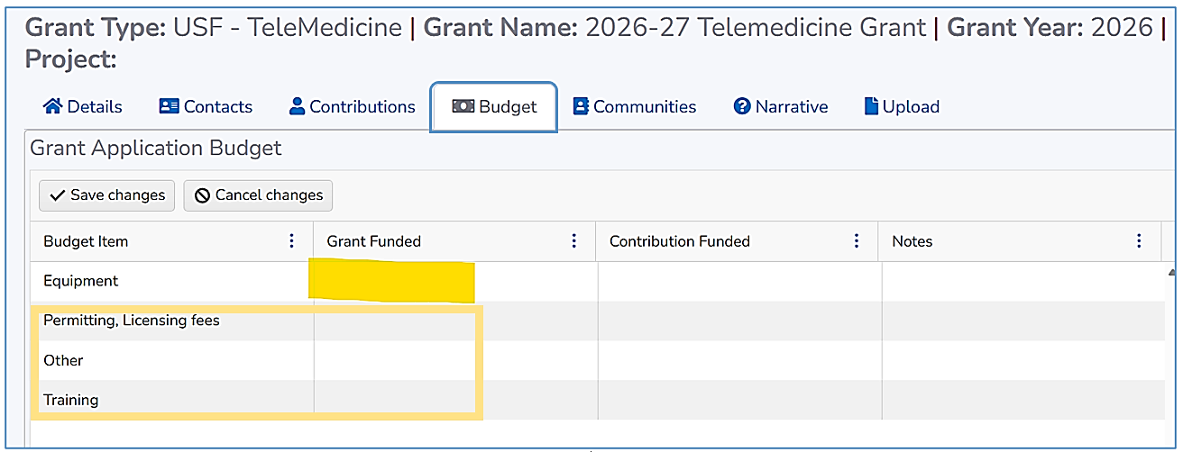
Grant System - Budget Tab image – Sample only

