FACILITATOR GUIDE

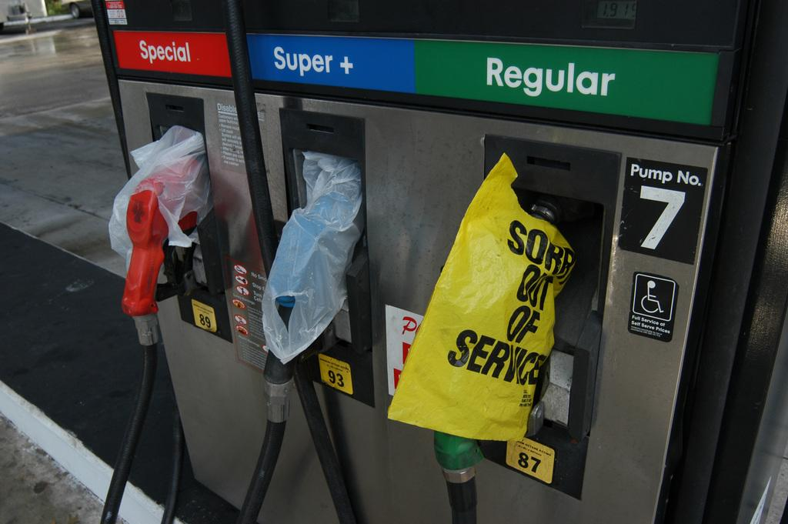
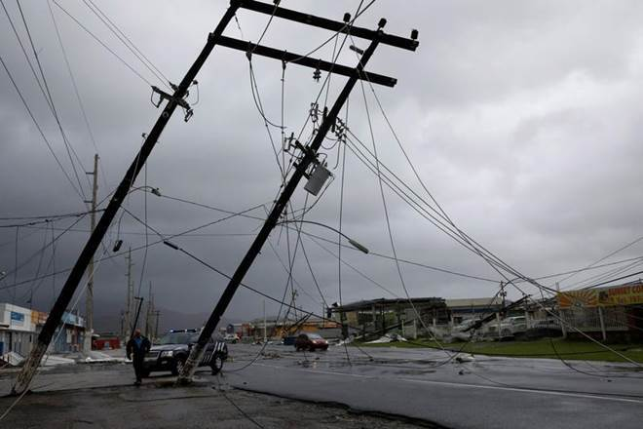
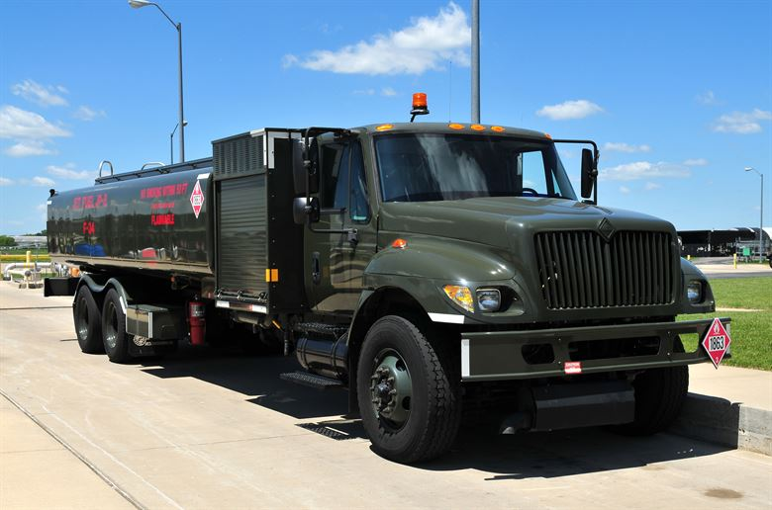
Emergency Fueling During a Power Outage
Virtual Tabletop Exercise
P-L (10/2020)
Introduction
In order to support local jurisdictions with all-hazards preparedness planning and exercises Wisconsin Emergency Management and the Wisconsin Office of Energy Innovation have developed a virtual facilitated discussion exercise (Virtual Tabletop Exercise) that is focused on a fuel shortage caused by severe weather and an associated long-term power outage. This facilitator's Guide is intended to be a tool for the use of emergency management offices throughout the State of Wisconsin.

This facilitator guide will assist the lead facilitator in effectively scheduling, initiating, and guiding the Virtual Tabletop Exercise. Note: these exercises can also be done in-person, when safe to convene.

Facilitated Discussion Overview
For this virtual facilitated discussion, your agency will schedule a time when all of the relevant stakeholders can attend virtually or physically distant for a tabletop exercise consisting of five modules. The tabletop exercise facilitator will introduce each module before pausing to allow participants to discuss issues, concerns, and opportunities related to the scenario they have been presented. A tornado scenario during a COVID pandemic has been created to guide this discussion. When the group completes a module, the facilitator will introduce the next module for discussion. This process will continue until all five modules have been completed.

Contents
In this guide you will find all of the tools necessary to successfully facilitate this discussion-based exercise. Included are:

    - Scheduling guidance
    - List of suggested attendees
    - List of materials needed
    - Tabletop outline
    - Facilitator guidance for each facilitated discussion module
    - Facilitator To-Do List--Appendix A
    - Sample Invitation--Appendix B
    - Sign in sheet--Appendix C
    - Participant Feedback Forms--Appendix D
    - Exercise Evaluation Guide --Appendix E
    - State Energy Profile Information – Appendix F

Questions
Please contact Paul Gazdik with any questions regarding the Virtual Tabletop Exercise (VTTX).

Paul Gazdik
Training and Exercise Officer
Wisconsin Emergency Management
paul.gazdik@wisconsin.gov
Office: 608-242-3336

For questions about energy emergency response, or the state petroleum shortage contingency plan, contact Megan Levy (OEI) or Drew Werner (WEM).

Megan Levy
Local Energy Programs Manager and Energy Emergency Assurance Coordinator
Wisconsin Office of Energy Innovation
Megan.levy@wisconsin.gov
Office: 608-266-5054
Cell: 608-800-2277
Drew Werner
Critical Infrastructure Planning Specialist
Wisconsin Emergency Management
Drew.werner@wisconsin.gov
Office: 608-888-5348
Cell: 608-852-3089

Scheduling Guidance
We recommend scheduling no less than two hours for your agency’s facilitated discussion. You will need to secure a location that has both audio and visual capabilities, as well as internet access. Please refer to Wisconsin Emergency Management

Suggested Attendees
We recommend that you invite the people and/or agencies listed below to participate in your discussion. If there are additional partners you would like to invite beyond the list provided, please do so.

A sample invitation letter is included as Appendix B for your convenience.

Attendees:
    - Emergency Management
    - Public Works and County Highway
    - Law Enforcement
    - Fire Department
    - Fuel vendors
    - County or Tribal Finance/Procurement
    - Local Electric Utility Liaisons

Materials Needed
To guide the facilitated discussion, you will need to provide the following documents.

    - Jurisdiction specific Emergency Operations Plan (EOP)
    - Virtual Tabletop Exercise Scenario Presentation
    - State Energy Profile Overview
    - Facilitator To-Do List—Appendix A
    - Participant Invitation Letter--Appendix B
    - Participant Sign in sheet--Appendix C
    - Participant Feedback Forms--Appendix D
    - Exercise Evaluation Guide--Appendix E

Outline
This section will explain the purpose and objectives of the virtual tabletop exercise, as well as provide an opportunity for introductions with your participants. We recommend tribes or counties using this guide provide participants with general information about energy usage in the tribe or county for participants (electric service territories, fuel terminals, major vendors, etc.)

[Tribal or County] Energy Overview | Facilitated Discussion
•Electric service territories  •Define critical services  •Fuel distribution locations  •Backup generators at critical infrastructure | •Objectives  •Introduction of facilitated discussion guidelines and structure  •Virtual Tabletop Exercise Scenario Presentation

Module One
Facilitate participant introductions, provide an explanation of exercise format, discuss exercise ground rules, and review core capabilities and exercise objectives.

Module Two
This module will look at initial actions that your jurisdiction will take to respond to a severe storm which causes a power outage. How do you assess the damage? What steps does your jurisdiction take in this scenario? How do you receive and share information with the energy sector?

Module Three
This module will focus on how agencies in your jurisdiction plan to continue operations during a long-term power outage. How is emergency fueling accomplished? Who tracks payments? How do agencies communicate fuel needs with one another? What response plans do fuel vendors have in place? What coordination takes place between private fuel vendors and emergency management?

Module Four
Conduct facilitated Hot Wash with exercise participants to capture jurisdictional strength and areas for improvement as identified during this virtual tabletop exercise.

Facilitator Guidance for Discussion Modules
The information in the tables below should be used to help guide the group through the discussion in each module. This information in these tables may not be included directly in the Virtual Tabletop Exercise Scenario Presentation. This information is not required to be shared but can help guide, initiate, or clarify discussion points as needed.

Module One—Introductions, Format, Ground Rules, and Purpose of Exercise
Recommend time for discussion: 5 Minutes
Introductions: Name, Agency, Role within your organization
Format: Virtual Facilitated Discussion
Ground Rules:
- Avoid distractions like email, phone calls, or work not related to this exercise
- Respect other participants and their contributions to the exercise
- Contribute to the discussion
- Enjoy the exercise and learn

Purpose: Exercise Objectives and Core Capabilities

Objectives | Core Capability
Evaluate [tribal or county] emergency operations plans and procedures as they relate to ESF-12 Energy [or energy incident annex] | Planning
Discuss how an energy shortage [propane, electrical outage, diesel and gas shortage] changes your established logistics and critical resource management procedures | Logistics and Supply Chain Management
Identify how your [tribe or county] defines critical services in an emergency (Example: points of distribution, fueling first responders, critical care facilities, and generators) | Logistics and Supply Chain Management
Discuss and analyze the transportation, tracking, and management of resources and associated costs | Logistics and Supply Chain Management
Discuss your command structure for this scenario | Operational Coordination

Module Two—Storm Preparation and Initial Response
Recommended time for discussion: 20 Minutes
Recommended Questions and Topics for Discussion:
- Topics:
  - Weather forecast and storm severity warnings
  - Mass Notification Systems
  - Damage Assessment Process
    - Power outage locations and restoration estimates
    - Road closures and other damage
  - Debris removal
  - Establish Incident Command and coordinate response agencies
  - Operational coordination between key agencies
- Recommended Discussion Questions:
  - Slide 13 (Exercise Scenario Background)
    - What actions do petroleum companies take if any when bad weather is forecast?
  - Slide 14
    - How do you determine the damage and impact of the storm? How do you learn about where power is out?
      - Does emergency management have a specific contact at the electric utilities they work with to receive outage info and/or coordinate response actions?
    - Who makes the decision to activate your emergency response plans?
    - Is your EOC activated at this stage?
      - Who reports to the EOC if it is activated?
    - Does your EOC have a backup generator?
    - If the power is out, how are you communicating with other entities?
    - If cellular networks are damaged by the storm and not working, how does this change your response?
    - How do petroleum companies determine impact to their facilities? Can you pump fuel without power? What if cell phones are not working? What impacts does that have on your ability to coordinate fuel deliveries?
  - Slide 15 (Next Day)
    - How does the initial estimate of a week without power change your response?
    - What are your initial concerns upon hearing that estimate?
    - What key facilities in your jurisdiction have backup generators? Do you know what types? How long do they run for approximately?
    - If your EOC has a generator, who is responsible for ordering fuel for the generator in an emergency?
    - Do gas stations in your area have backup generators?
    - Do highway shops in your area have backup generators?
    - How do fuel vendors operate in a situation like this?
      - What emergency plans do you have to provide fuel to customers in the event of a widespread power outage?
      - Would you work with other vendors to supply customers if you couldn’t? Would you obtain product from other vendors to deliver it or have another company deliver it?
      - What information might you need from local authorities to operate in these conditions.
    - How do you coordinate response with electric utilities?
      - Can debris clearance efforts be coordinated with electric utilities? ‘
      - How is this accomplished?

Module Three— Long Term Power Outage Response & Emergency Fueling
Recommended time for discussion: 50 Minutes
Recommended Questions and Topics for Discussion:
- Topics
  - Emerging Issues – 48 hours in
  - Fueling
  - Utility Mutual Assistance and Response
  - Coordination with outside agencies for assistance
- Questions:
  - Slide17 (48 Hours After Storm)
    - How do emergency services get fuel in a situation like this? Is that source available during this power outage? What’s the contingency plan?
    - What might utilities need to support restoration operations? What items are utilities concerned with when hundreds of outside crews begin to arrive?
      - Lodging
      - Fuel
      - Feeding
    - What counts as an emergency service or critical service in this situation? Are utilities considered responders? Can they obtain fuel at emergency fueling stations set up by your jurisdiction? What about telecommunications providers?
    - How would your EOC handle a request from a facility to receive fuel for their generator? Who do you coordinate with? How do multiple requests get prioritized?
    - What critical infrastructure are you concerned with at this point? Are certain sites in danger of shutting down if they run out of fuel?
    - Do fuel vendors that service your jurisdiction have the capability to pump and sell fuel during a power outage? What challenges or limitations to these functions might a widespread outage cause?
    - If electric utilities or other private sector partners require fuel can they utilize your jurisdictions fuel points of distribution? How are they billed for fuel received? How is this tracked? Where is this tracked?
  - Slide 18 (Final Scenario Update)
    - Who is tracking where power has been restored?
    - How would dairy farms be resupplied if their primary vendor could not provide fuel? Would the county get involved?
    - What steps, if any, would you take to address fuel shortage rumors and long lines at gas stations?
    - What steps do fuel vendors take when lines and/or fights occur at gas stations?
      - Who decides what steps to take?
      - Are these steps coordinated with local authorities? If so, Who?
      - Do fuel company public affairs departments (or corporate communications) send out messages in a situation like this? If so, what platforms are utilized? Who is the target audience? Are these messages coordinated with other agencies?

Module Four—Exercise Hotwash
Recommended time for discussion: 15 Minutes
Strengths | Areas for Improvement
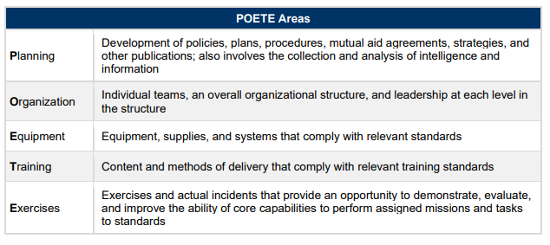

Appendix A: Facilitator To-Do List

Immediately:
- Read the entire Facilitator Guide
- Determine who will be invited to your facilitated discussion, both internally within your departments and additional external partners.
- Set a date and time for the facilitated discussion.
- Make the reservation for a physical or virtual meeting space for the specified date and time.
- Invite everyone identified above to the facilitated discussion. A sample invitation letter is included as Appendix B for your convenience.

At least one week prior to the facilitated discussion date:
- Assemble the necessary materials:
    - Jurisdiction Specific Emergency Operations Plan (EOP)
    - Tabletop Exercise Scenario Presentation
    - Facilitator To-Do List—Appendix A
    - Participant Invitation Letter--Appendix B
    - Participant Sign in sheet--Appendix C
    - Participant Feedback Forms--Appendix D
    - Exercise Evaluation Guide--Appendix E
    - State Energy Profile Overview – Appendix F
    - Tribal or County Energy Profile Information – Appendix G (optional)
- Disseminate virtual meeting location link, participant login information, and exercise date and time to anticipated exercise participants.

The day of the facilitated discussion:
- Confirm and test virtual meeting space to assure the audio and visual capability of the room are functioning.
- Welcome everyone to the discussion and make sure they sign in.
- Initiate introductions with the participants in the room.
- Follow along with the shared Virtual Tabletop Exercise Scenario Presentation slides.
- Refer to the guidance for each module on pages four through seven of the Facilitators Guide.
- Monitor the time during each module to assure you complete the exercise on schedule.
- Thank everyone for coming and remind them to complete and submit their Participant Feedback Forms.

After the facilitated discussion:
- Collect all the materials, participant sign-in sheet, participant feedback forms, and exercise evaluation guides.
- Email participant sign-in sheet, participant feedback forms, exercise evaluation guides, and Hot Wash notes paul.gazdik@wisconsin.gov
- Schedule and reserve a virtual meeting space to present finding of the Virtual Tabletop Exercise After Action Report and Improvement Plan 60 days after the completion of your Virtual Tabletop Exercise

Appendix B: Sample Invitation Letter

Date: _____________

Dear ,

You are cordially invited to participate in the [insert jurisdiction] emergency fueling tabletop exercise. This exercise will allow participants to discuss how critical services and emergency response personnel in [insert jurisdiction] obtain fuel during a long-term power outage caused by severe weather.

Severe storms in Wisconsin have caused long-term power outages in the past. In July 2019, a line of severe storms knocked out power to a large swath of north central Wisconsin, with some areas not getting power back until 10 days after the storm. In April, 2011, multiple tornados caused damage in the same region and knocked out power for several days. These storms each featured straight line winds of greater than 80 mph and several tornados. Though storms of this magnitude are relatively rare, they can impact a wide area and force public, private, and volunteer emergency responders to deal with several simultaneous challenges.

In an effort to discuss and plan for some of these challenges, a Virtual Tabletop Exercise Scenario has been prepared to assist our community in taking steps to provide that support and safety to residents impacted during storm events such as these.

We consider your agency as critical partner in the effort to respond to and serve the people in our communities impacted by severe weather events. Please join us to discuss, identify, coordinate, and deliver resources to our communities in response to a long-term power outage event [date] from [start time-end time] at [virtual meeting space link].

Please RSVP for this Virtual Tabletop Exercise by responding to this letter with the names and numbers of participates your agency intends to participate in the facilitated discussion.

Thank you for your partnership,

[Name]
[Position/Title]
[Organization]

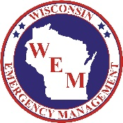 | Wisconsin Emergency Management  Sign In Sheet
COUNTY: TYPE OF EXERCISE:

EXERCISE OFFICER: DATE:
LOCATION:

 | Name | Agency/Department | Phone Number
1.
2.
3.
4.
5.
6.
7.
8.
9.
10.
11.
12.
13.
14.
15.
16.
17.
18.
19.
20.

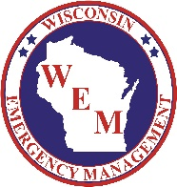 | Wisconsin Emergency Management  Sign in Sheet

Your feedback on the success and shortcomings of this tabletop/functional exercise is very valuable as we continue to increase preparedness at the local level. Please take a few minutes to complete this evaluation.
Please circle the number in the column that best describes whether you strongly disagree, disagree, agree, or strongly agree with each statement.
 |  | Strongly Disagree |  |  |  | Strongly Agree
a. | The exercise was well structured and organized. | 1 | 2 | 3 | 4 | 5
b. | The exercise scenario was plausible and realistic. | 1 | 2 | 3 | 4 | 5
c. | The facilitator/controller(s) was knowledgeable about the area of  play and kept the exercise on target. | 1 | 2 | 3 | 4 | 5
d. | The exercise documentation provided to assist in preparing for and participating in the exercise was useful. | 1 | 2 | 3 | 4 | 5
e. | Participation in the exercise was appropriate for someone in my position. | 1 | 2 | 3 | 4 | 5
f. | The participants included the right people in terms of level and variety of disciplines. | 1 | 2 | 3 | 4 | 5
g. | This exercise allowed my agency/jurisdiction to practice and  improve priority capabilities. | 1 | 2 | 3 | 4 | 5
h. | After this exercise I believe my agency/jurisdiction is better prepared to deal successfully with the scenario that was exercised. | 1 | 2 | 3 | 4 | 5

For any of the above statements that you disagreed or strongly disagreed with, please provide input on how those areas could be improved.
- Based on the exercise today, what were the top 3 strengths?

- Based on the exercise today, what were 3 areas that needed improvement?

- List the applicable equipment, training, policies, plans, and procedures that should be reviewed, revised or developed. Indicate the priority level for each.

Please complete this form prior to checking out for the day and turn it into an evaluator.

Exercise Evaluation Guides

Evaluator Name:
Return to: paul.gazdik@wisconsin.gov Cell: 608-242-3336

Core Capability | Planning
Objective: Evaluate [tribal or county] emergency operations plans and procedures as they relate to ESF-12 Energy

Task
Were participants of the exercise aware of who could activate the [insert jurisdiction] Emergency Fuel Management Annex?

Did participants discuss how fuel companies are involved in the emergency fuel management planning?

Did participants discuss and identify the roles of the various participating agencies in development and maintenance of the [insert jurisdiction] Emergency Fuel Management Annex?

Does the Emergency Fuel Management Annex have procedures for supplying the types of fuel required by critical services in [insert jurisdiction]? This may include propane, diesel fuel, gasoline, and other fuels.

Core Capability | Planning
Objective: Evaluate [tribal or county] emergency operations plans and procedures as they relate to ESF-12 Energy

Activity Analysis
Analysis: (one or two paragraphs summarizing this Capability)

Strengths:

Areas for Improvement:

Additional Observations:

Exercise Evaluation Guides

Exercise Evaluation Guides

Evaluator Name:
Return to: paul.gazdik@wisconsin.gov Phone: 608-242-3336
Core Capability | Logistics and Supply Chain Management
Objective: Discuss how a fuel shortage associated with a power outage changes your established logistics and critical resource procurement.

Task
Did the participants discuss the decision-making process for activation of critical resource and logistics activities.

Did the participants discuss the notification procedures for staff and agencies included in the plan?

Did the participants discuss backup methods of communication that could be utilized to notify stakeholders if primary systems (cell service) are unavailable?

Did the participants discuss what equipment, supplies, and forms are needed by personnel at fuel points of distribution?

Core Capability | Logistics and Supply Chain Management
Objective: Discuss how a fuel shortage associated with a power outage changes your established logistics and critical resource procurement.

Activity Analysis
Analysis: (one or two paragraphs summarizing this Capability)

Strengths:

Areas for Improvement:

Additional Observations:

Exercise Evaluation Guides

Evaluator Name:
Return to: paul.gazdik@wisconsin.gov Cell: 608-242-3336
Core Capability | Logistics and Supply Chain Management
Objective: Identify how your [tribe or county] defines critical services in an emergency (Example: points of distribution, fueling first responders, critical care facilities, and generators)

Task
Did the participants discuss how the [tribe or county] determines what qualifies as a “critical service” during this scenario?

Did the participants discuss notification of critical services that fuel points of distribution (FPODS) are active?

Did the participants discuss how and when fuel vendors are notified that FPODs are active?

Did participants discuss how requests for fuel from facilities are prioritized?

Did participants discuss whether volunteers and other private organizations have access to FPODs during a
Disaster and how they identify themselves as eligible recipiants?

Core Capability | Logistics and Supply Chain Management
Objective: Identify how your [tribe or county] defines critical services in an emergency (Example: points of distribution, fueling first responders, critical care facilities, and generators)

Activity Analysis
Analysis: (one or two paragraphs summarizing this Capability)

Strengths:

Areas for Improvement:

Additional Observations:

Exercise Evaluation Guides

Evaluator Name:
Return to: paul.gazdik@wisconsin.gov Cell: 608-242-3336
Core Capability | Logistics and Supply Chain Management
Objective: Discuss and analyze the transportation, tracking, and management of resources and associated costs

Task
Did participants discuss how agencies purchase fuel during steady state operations?

Did participants discuss how fuel purchases are tracked and processed during emergencies?

Did the participants discuss coordination with fuel vendors for delivery of addition fuel to FPODs and critical facilities if needed?

Did participants discuss who is responsible for tracking burn rates, ordering additional fuel, and tracking associated costs during a scenario like this?

Did participants discuss existing fuel industry methods for delivery and tracking of fuel to customers during a power outage?

Core Capability | Logistics and Supply Chain Management
Objective: Discuss and analyze the transportation, tracking, and management of resources and associated costs

Activity Analysis
Analysis: (one or two paragraphs summarizing this Capability)

Strengths:

Areas for Improvement:

Additional Observations:

Exercise Evaluation Guides

Evaluator Name:
Return to: paul.gazdik@wisconsin.gov Cell: 608-242-3336
Core Capability | Operational Coordination
Objective: Discuss your command structure for this scenario

Task
Did the participants discuss how the incident is managed (ICP, EOC, etc.)?

Did the participants discuss if/how the electric utilities and fuel industry coordinate with or participates in the command structure during a power outage or fuel shortage?

Did the participants discuss which agencies are expected to staff the [tribal or county] EOC in this scenario?

Did participants discuss the role of [tribal or county] leadership in this scenario?

Core Capability | Operational Coordination
Objective: Discuss your command structure for this scenario

Activity Analysis
Analysis: (one or two paragraphs summarizing this Capability)

Strengths:

Areas for Improvement:

Additional Observations:

